# Ethics

# CNN related news about making a speech, e.g.

<http://edition.cnn.com/2014/09/30/world/asia/china-hong-kong-protests/index.html>

## (social issue: **civil disobedience**) “civil disobedience” in HK (during HK’s universal suffrage)

**Hong Kong (CNN)** -- Wednesday is National Day, a day for all Chinese to celebrate the People's Republic of China.

Yes, **dignitaries** /ˈdɪɡnɪtərɪ/ gathered and ceremonies took place to mark the holiday in Hong Kong. But the national pride mixed with profound **dissent** as **pro-democracy(支持民主)** protesters occupied parts of the Asian business hub -- not to celebrate the central government in Beijing, but to **denounce (criticize in public强烈谴责)** and challenge it.

There was a sense that the protest ranks could **swell** with more people off work for the holiday. The movement has seemingly grown regardless, unaffected by clashes with police, thunderstorms and repeated **admonitions** by authorities who have refused to **budge** (relent sb’s attitude, sort of give in/submit to/yield to a little bit 缓和下态度，稍微让步).

So there they were, Wednesday morning, waking up to **chants** over loudspeakers calling for the local chief executive's **resignation**, for police not to use violence against them and for everyone to "protect Hong Kong."

Student **pro-democracy(支持民主)** leader Joshua Wong, who was arrested/**apprehended** during protests Friday and released Sunday, led a group of students in a **sit-in** protest at the official National Day **flag-raising ceremony** in Golden Bauhinia Square. The group silently turned their backs to the flag and raised their arms in crosses as the Chinese flag and the flag of Hong Kong were raised.

"We crossed our arms because we want to express our **dissatisfaction and disappointment** toward the government, to reflect our mistrust towards the central Chinese government, and to **object to** the National People's Congress decision on August 31," he said, referring to [Beijing's **controversial** ruling](http://www.cnn.com/2014/08/31/world/asia/hong-kong-elections/index.html) to allow only candidates approved by a nominating committee to run for office as Hong Kong's chief executive.

In the build-up to the flag-raising, a statement from Wong's group calling for calm and restraint during the ceremony was widely **circulated** among protesters on social media networks. "Just wear black, stay quiet with your chin down or carry an umbrella," read a message. "No matter how much you dislike a country, disturbing its **flag-raising ceremony** will only be unethical, unacceptable and disrespectful." Then again, there was also no sign that BJ authorities are ready to **budge (relent sb’s attitude, give in (submit to/yield to 屈服;让步).**

"Both sides appear to be **digging in their heels 固执己见(不理会其他人的意见)**," When it was transferred from British to Chinese control in 1997, Hong Kong **was supposed to be** the centerpiece of Beijing's one nation, two systems approach. Semi-autonomous

But protesters fear that independence is **slipping away**. They **decry** a recent decision allowing national government leaders to **vet** -- **in other words**, decide who is in and who is out -- any candidates up for a vote to lead Hong Kong's government.

Changing that policy is demand No. 1 for the protesters, who say that having every citizen get a vote in an election **(universal suffrage)** is **moot (practically meaningless无实际意义的)**  if the options are decided in Beijing. A growing number have also **denounced** Hong Kong's current leader for putting the central government ahead of his own citizens and demanded he step down.

One demonstrator explained to CNN's Watson: "(We want the government) just to respect the democracy that Hong Kong deserves and really **uphold** the principle of one country, two systems." The powers-that-be don't appear to be in much of a talking mood. They have refused to **budge (changing sb’s attitude, sort of give in/submit to/yield to a little bit)** while condemning the protests, which they say are against the law and are undermining Hong Kong's economic and security.

"It is **definitely** better to have the (chief executive) elected in a **universal suffrage** by five million **eligible** voters than by 1,200 people. And it is **definitely** better to **cast your vote/ballot** at the **polling station** than to stay home and watch on television the 1,200 members of the Election Committee cast their votes."

Like other chief executives, Leung wasn't elected by a popular vote but rather by a 1,200-strong committee stacked with Beijing loyalists. That was set to change in 2017. Leung points out that "we will be able to have one-person, one-vote" -- meaning citizens, not just committee members, can **cast ballots/votes.** "I understand this **universal suffrage** is **somewhat/a little** different to what the public thinks it would be," he said. "But this is based on the basic law. We still want to remain peaceful, calm and think what the best is for Hong Kong."

Leung has backing from **pro-Beijing** (支持BJ) groups like [The Silent Majority for Hong Kong](http://www.silentmajority.hk/showroom/model/T0199-blue/templateCustomWebPage.do?customWebPageId=1378455424296000289&webId=1378411927359000128&editCurrentLanguage=1378411927453000130), who have had their own rallies and run **advertising campaigns (一系列广告)** to **preach**(散布宣扬) their message that pro-democracy**(支持民主)**  activists will "endanger Hong Kong", create **chaos**/**unrest**, and **ferment/brew** a “coup plot” to **overthrow/topple down** Chinese regime (推翻政权).

Officials in the city have spoken out against the protest and acted out. That's when police **hurled(猛投；猛掷)** 87 **tear gas** **canisters** and unleashed **pepper spray** into the crowd after they refused to heed calls to disperse, spurring protests. Such forceful **sentiment** aren't being heard everywhere, however.

**Activist: 'It's more or less like North Korea'**

Even as censors [blocked access to Instagram](http://money.cnn.com/2014/09/29/technology/instagram-blocked-china/index.html) after images of protests flooded the photo-sharing app and China blocked out reporting on Hong Kong in mainland China, those on the streets managed to make their voices heard in other ways. Some took to Twitter, and a few turned to CNN iReport -- including one capturing [a collective of umbrellas](http://ireport.cnn.com/docs/DOC-1174755) which, besides shielding at times **torrential rain,** have become symbols of the protests

## (social issue: civil disobedience) Hong Kong's leader to protesters: China won't **back down/concede/yield to 让步**

<http://edition.cnn.com/2014/09/29/world/asia/china-hong-kong-protests/index.html>

Thousands of demonstrators bracing for the possibility of a police **crackdown** stood their ground in the heart of Hong Kong on Tuesday. Protesters had masks, **protective goggles** and plastic raincoats on hand as they camped out on the main **thoroughfare**大道 leading into the city's **central business district (CBD).**

It's been more than a day since officers **fired tear gas and unleashed pepper spray** at the crowd.For 2nd night in a row, **pro**-democracy demonstrators occupied the highway in downtown Hong Kong, sleeping on pavement. At least 56 people have been injured so far in the largely student-led protests, which **flared into violence(**燃烧**)** and sparked natinal(HK’s) fury ( 激起的愤怒) starting Sunday, a Hong Kong government spokeswoman said.

The head of the HK government urged protesters to clear roads Tuesday, saying they are **impeding/hinder/hamper** any emergency vehicles that may need to pass. "The main roads are used by fire trucks and ambulances. They now have to take a reroute or even **detour**, so we urge the society to think about this".

Demonstrations began in response to China's decision to allow only Beijing-vetted candidates to stand in the city's 2017 election for the top civil position of chief executive. Protesters say Beijing has gone back on its pledge to allow **universal suffrage** in Hong Kong, which was promised "a high degree of autonomy" when it was [handed back to China by Britain in 1997](http://www.cnn.com/2014/09/29/world/asia/hong-kong-protest-backgrounder/index.html).

Leung said Tuesday that China will not back down from its position on Hong Kong. "China will not **budge/back down** at this point, which means China will not **compromise/submit/yield to/compromise/back down** the illegal threats of some people," he said. "Based on the basic law, we will be able to have one person, one vote **universal suffrage**. China's decision is based on and using what the basic law allows them to do."

But the protesters, **rallying** against what many see as the growing influence of the Chinese Communist Party on the way Hong Kong is run, are so far refusing to **budge (relent sb’s attitude, sort of give in/submit /yield/comprise/back down a little bit 缓和态度，有一点点的让步 )**

A large orange **banner** hanging over them, Stevens reported, says "freedom in the midst of a storm." Demonstrators say they're not going anywhere. Authorities also don't seem to show any sign of **backing down/budge/compromization/submission/yield**; officials in Hong Kong and China say it's an illegal gathering.

The large-scale demonstrations now taking place grew out of student-led **boycotts** and protests that began last week. The demonstrations increased in size over the weekend after gaining the support of Occupy Central with Love and Peace, a protest group that was already planning to lead a campaign of **civil disobedience** later this week against the Chinese government's decision.

Images of heavy-handed treatment of protesters by police shocked many residents of Hong Kong, where large-scale, peaceful protests are common, but police crackdowns are not. CNN's Ivan Watson -- [who himself was enveloped in a cloud of stinging tear gas Sunday](http://edition.cnn.com/video/data/2.0/video/international/2014/09/28/cnni-lkl-watson-hk-protests-crew-gassed.cnn.html) -- said protesters and police appeared unused to the method of crowd control.

"Both sides were appealing for calm, and then **the tear gas and pepper spray** just exploded in the midst of everybody, people here have never been hit by tear gas before, and it comes as quite a shock to them. This is a big shock for a city that is famed for its law and order."

The strong police response appeared to stir thousands more people into joining the demonstrations, **swelling** the ranks of protesters around the government headquarters and starting new **rallies** in other key areas of the city, including **the densely populated district** of Kowloon, which sits on the opposite side of Victoria Harbor from Hong Kong Island.

## (Unethical social issue: bribery and crime) Ousted SK president apprehended/arrested

Former South Korean President Park Geun-hye, who was removed from office/ousted from office 罢黜; 把…撤职earlier this month, was apprehended/arrested on Friday. "Major crimes have been ascertained and there is a concern that the suspect might attempt to destroy evidence," Judge Kang Bu-young said in a text message to reporters.

"The court recognizes the need, **necessity** and **reasonableness** of the suspect's arrest." [Prosecutors announced Monday](http://www.cnn.com/2017/03/27/asia/south-korea-park-geun-hye/) that they were seeking to arrest Park on charges relating to abuse of power, accepting bribes, **embezzlement**挪用公款, and leaking important information. "The suspect abused the **mighty** power and position as President to take bribes from companies and **infringed** upon the freedom of corporate management and leaked important confidential official information.

Park had been held in a temporary **detention** facility at the Seoul Central District Prosecutor's Office Building ahead of the court's decision. She was taken to Seoul **Detention** Center on Friday, the same location where her **confidant** Choi Soon-sil and some of the **high-profile figures/dignitary高官;显要人物** who **were embroiled in** the ongoing scandal, including Samsung **heir**[eə] Lee Jae-yong, have been **detained**.

// someone **embroils** you **in** a fight or an argument, they get you deeply involved in it. 使卷入(战斗或争论)

Park has not yet been formally **indicted**/**accused**, prosecutors said. Prosecutors can **detain** Park for up to 20 days before formally charging/indicting her. Park was removed from office/**ousted from office罢黜; 把…撤职** on March 10, after South Korea's Constitutional Court upheld a decision to **impeach**弹劾 her for alleged corruption.

The former President was accused of helping a **confidant** [raise donations from companies for foundations she had set up.](http://www.cnn.com/2016/11/02/asia/south-korea-president-scandal-explained/index.html) The scandal dominated the headlines in South Korea and prompted mass protests when it emerged late last year. The controversy centered around Park's friend and close adviser, Choi, who is alleged to have significant and **ina**ppropriate[**ɪnə**'prəʊprɪət] influence over Park. Choi is on trial for abuse of power and **fraud**.

The [Constitutional Court's **impeachment**弹劾 ruling](http://www.cnn.com/2017/03/10/asia/south-korea-president-park-geun-hye-impeachment/) stripped Park of her **presidential immunity**豁免权 and cleared the way for prosecutors to seek her arrest. A presidential election will be held on May 9 to choose a new leader.

## (Unethical social issue: bribery and crime) Samsung heir [ɛr] Lee Jae-yong jailed for corruption

<http://www.bbc.com/news/business-41033568>

* chaebol /ˈtʃeɪbɒl/ or conglomerate

1.N a large, usually family-owned, business group in South Korea 韩国财团 [The chaebol 财阀; Korean Chaebol 韩国财阀; Chaebol group 家族企业集团 ]

**What is a chaebol or conglomerate?**

* The word chaebol is a combination of the Korean words for clan and wealth
* It is the name given to South Korea's massive family-run business empires that wield huge influence in the country
* They normally own numerous international enterprises
* Other examples include LG, Lotte and Hyundai
* grip 强烈地影响(大众)　［grip the public ］

e.g. The court in South Korea has **sentenced Samsung's heir [ɛr] Lee Jae-yong to five years in prison** for corruption, bribery, and **embezzlement** **[ɪm'bɛzlmənt]挪用公款**. Lee was convicted宣告有罪 of bribery in a scandal that also saw the **impeachment弹劾** of South Korea's former president. The case has **gripped(强烈地影响) the public** amid growing anger against South Korea's biggest companies, known as **Korea chaebols/ˈtʃeɪbɒl/** or **conglomerate [kən'ɡlɑːmərət] 企业集团**.

* 做xxx**不知情** [ do sth without sb’s knowledge ]

e.g But Lee's defense team said that the payments were signed off **without his knowledge不知情.**

The court in South Korea has **sentenced Samsung's billionaire heir [ɛr]-apparent Lee Jae-yong to five years in prison** for corruption, bribery, and **embezzlement** **[ɪm'bɛzlmənt]挪用公款**. Lee was convicted宣告…有罪 of bribery in a scandal that also saw the **impeachment弹劾** of South Korea's former president.

The case has **gripped(抓住控制;强烈地影响) the public** amid growing anger against South Korea's biggest companies, known as **Korea chaebols/ˈtʃeɪbɒl/** or **conglomerate [kən'ɡlɑːmərət] 企业集团**. Lee, Samsung's billionaire **heir**,who **denied all charges**, had faced a jail sentence of up to 12 years. Also known as Jay Y Lee, the **de facto leader** of the world's largest smartphone maker had been detained since February on a string of corruption charges. These included bribery, embezzlement**挪用公款** and hiding assets overseas.

**What did he do?**

The 49-year-old **is accused of/indicted for** giving donations worth 41bn won to non-profit foundations operated by Choi Soon-sil, the **知心女友confidante** of South Korea's former President Park Geun-hye, **in return for** political favours.

Prosecutors said the donations were made to Ms Park's confidante to win government support for a big restructuring of Samsung that would strengthen Lee's **grip**/control over Samsung Electronics.

But Lee's defense team said that the payments were signed off **without his knowledge不知情.** Lee has previously admitted that the firm also gave a horse and money to help the equestrian career of Choi's daughter, Chung Yoo-ra, but denied seeking favours. His lawyer said on Friday they would **appea[l a]gainst** the court's decision."We are confident that the ruling will be **overturned**"

**Who else is involved?**

The case contributed to President Park's eventual **impeachment** and she now faces trial for corruption herself, something she denies. Her **confidante** Choi has already been jailed for [three years after being found guilty](http://www.bbc.co.uk/news/world-asia-40377564) of using her position of influence to **solicit favours (请求给予好处)for** her daughter.

**Will Lee serve time in jail?**

This isn't the first time a top executive of a big Korea **chaebol/conglomerate** has been **convicted宣告…有罪** for **corruption, bribery, and embezzlement** in South Korea. But in the past, they've either been given suspended sentences or have been **pardoned** by the president. The new president, Moon Jae-in, has already said there will be no more **presidential pardons.**

So if Lee's sentence is upheld by higher courts and he **ends up** serving his complete sentence in jail or a significant part of it, that will be a departure from what we've seen in South Korea in the past. And the new government says that will be a strong message to **chaebol/conglomerate** that they need to clean up the way they do business.

**What does it mean for Samsung?**

The **conviction** represents a huge blow to South Korea's biggest and most well-known business empire. Since the **verdict**, Samsung shares fell by 1%. It also **raises questions about** the future leadership of the family-run **chaebol/conglomerate**. Lee has been standing in as chairman since his father, Lee Kun-hee, suffered a heart attack in 2014.

Lee has two sisters, who are in management roles in different parts of the Samsung group, but it is unclear whether they could be brought in to higher positions. Since Lee's arrest six months ago, the group's business operations have continued largely unaffected.

The Samsung Group, made up of 60 interlinked companies, is crucial to the South Korean economy, with sales equivalent to about a fifth of the national GDP. The Korea **chaebol/conglomerate** includes a shipbuilding division, a construction company, and pharmaceuticals and advertising arms.

**What is a chaebol or conglomerate?**

* The word chaebol is a combination of the Korean words for clan and wealth
* It is the name given to South Korea's massive family-run business empires that wield huge influence in the country
* They normally own numerous international enterprises
* Other examples include LG, Lotte and Hyundai

## (Unethical social issue: bribery and crime) South Korea President got impeached for being embarrassing

South Korea's first female president, Park Geun-hye, is now also the nation's first **impeached弹劾** president. The Korean **Constitutional** Court on Friday [voted](http://www.cnn.com/2017/03/10/asia/south-korea-president-park-geun-hye-impeachment/index.html) to remove her from office **unanimously**全体一致的,无异议的, and **snap elections** for a new president will be held within 60 days.

The subsequent media coverage **is rife with充斥着** comparisons between Park and Trump. Social media **sentiment** is similar, with tweets like "[Next to go is Trump](https://twitter.com/KJM9NY/status/840197405043806209)." However, **likening Trump to Park把…比作** demonstrates not just wishful thinking, but a **fundamentally** incorrect assumption that democracy is the same in every country. //liken A to B: compare A to B **把…比作**

I have no great love for Park, but it's hard not to notice that her **impeachment** is pretty much based on the Korean people's hurt feelings. She is possibly the first president of any democratic nation to be formally **impeached** for being embarrassing, stupid and **indiscreet**不慎重, but not for hard evidence of **graft**贪污/corruption, bribery, **embezzlement**挪用公款, or **perjury**伪证.

In America, there is no way that a president can be **impeached** for being embarrassing and stupid. In fact, it might be one of the only jobs in the United States where you can't be fired for that **sort of** thing.

What Park did/did not do: Bribery scandals circled Park, but never quite touched her directly: The **beneficiary** of the alleged bribes was not Park herself, but her closest **confidante**, [Choi Soon-sil](http://www.cnn.com/2016/11/02/asia/south-korea-president-scandal-explained/), the **cult异教团体** leader's daughter who **reportedly** [liked to make friends](http://www.koreatimes.co.kr/www/news/nation/2016/10/116_217091.html) in male **brothels**妓院. Though Korean prosecutors on January 25 **indicted Choi for** her role in the scandal, she [**vociferously** maintained](https://www.washingtonpost.com/video/world/woman-at-center-of-south-korean-corruption-scandal-protests-her-innocence/2017/01/25/c465d574-e2ed-11e6-a419-eefe8eff0835_video.html) her **innocence**.

It was an unlikely friendship: Park is a president's daughter; she speaks five languages and has an undergraduate degree in mechanical engineering. If she had wanted someone to review state secrets, she could have asked Korea's best and brightest or someone who had **security clearance** or, **at the very least**, an actual government employee. Upon Choi's death, his daughter Choi Soon-sil **assumed the role of** Park's "Chief Mental Influencer.".

By US legal standards, Park's impeachment is **peculiar/weird** **in that/because** she was **ousted**罢黜; 撤职 before even being fully investigated. Even the special prosecutors making the case against Park [**reportedly** claimed](https://www.washingtonpost.com/world/south-korean-prosecutors-say-president-colluded-in-corruption-scandal/2017/03/06/3bb618f2-df75-4348-bde5-8542af2df74f_story.html?tid=a_inl&utm_term=.6e11227ccece) they didn't have time to complete the inquiry and were **denied an extension emphatically/categorically.**

However, **even if** she had been linked to financial **malfeasance**/mælˈfiːzəns/(公共官员的)渎职行为, this crime would have been secondary to the Korean public. **After all,** in Korea, it has historically been the case that bribery **is synonymous with** presidency, and some of her **predecessors** literally **absconded/əbˈskɒnd/ with** billions of Korean wons. None of them was ever impeached, though several were prosecuted after leaving office**. //abscond with携带(某物)潜逃**

Park's main crime was that she ran one of the world's wealthiest nations based on the advice of **a cult异教团体 brat,** who had duped her. Choi touted her closeness to Park to cajole Korea's business **elite** (including Samsung **heir** Lee, who was [arrested in February](http://money.cnn.com/2017/02/16/technology/samsung-jay-lee-arrest-warrant/)) to donate money to **dubious** charities in exchange for implied presidential favors. Though a Korean prosecutor [alleged](http://www.cnbc.com/2017/03/06/skorea-special-prosecutor-president-park-colluded-with-friend-to-receive-samsung-bribe.html) that Park had knowledge of this -- and she may well have -- what is significant is that the impeachment was pushed through before the conclusion of the investigation.

[Women leaders **get boot for** corruption while men skate](http://edition.cnn.com/2017/03/10/opinions/ethic-standards-south-korea-ghitis/index.html): Three deaths and 30-odd serious injuries [were reported](http://www.cnn.com/2017/03/10/asia/south-korea-president-park-geun-hye-impeachment/) as having arisen from post-impeachment protests, but had Park not been impeached, a revolution with far more fatalities would have been inevitable. Her removal was probably the only outcome the Korean people would accept, and the Korean senate and courts knew that.

This does not mean that other democracies can impeach presidents based on annoyance and embarrassment, nor should they. Somewhat like the **Catholic** Church, democracy could only **disseminate** by adapting to the customs and history of the nations it entered. One of the chief areas of **divergence** lies in how a leader is **ousted**罢黜撤职; 驱逐.

Democracy's infinite adaptability: Korean democracy is very different from its American **counterpart**: The Korean democratic state is young. To play catch-up to Western democratic principles, it could only effect change through dramatic **upheavals** and revolutions. But you can't rely on that sort of gentleman's agreement elsewhere. It wouldn't work in Korea, because democracy there is too young and the rule of law is even younger. **Nor** would it work in the United States, which is ruled by its Constitution as no other country is. And what that means for presidential impeachment is that you need proof, proof and more proof of **wrongdoing**.

**In short,** the answer to the following question, "Are you allowed to **impeach** a president for gross incompetence?" Not in the United States, at least. Like it or not, it's the best way to prevent utter, near-**apocalyptic** /əˌpɒkəˈlɪptɪk/ chaos.

**apocalyptic** /əˌpɒkəˈlɪptɪk/:

* Apocalyptic means relating to the total destruction of something, especially of the world. (世界)末日的 e.g. ...the reformer's **apocalyptic** warnings that the nation was running out of natural resources....改革者的末日警告是
* Apocalyptic means relating to or involving predictions about future disasters and the destruction of the world. (世界)末日启示的 e.g：...a gloomy and **apocalyptic vision** of a world hastening toward ruin..一种世界正加速走向毁灭的阴郁和**末日启示的想法**

**malfeasance** /mælˈfiː**z**əns/(公共官员的)渎职行为: the doing of a **wrongful** or illegal act, by a public official or civil servant.

**cult: 异教团体**

## Other CNN news not related with “social issues” or “ethics”

## [Politic] Europe migrant crisis: EU court rejects quota challenge

<http://www.bbc.com/news/world-europe-41172638>

The EU's top court has rejected a challenge by Hungary and Slovakia to a migrant relocation deal drawn up at the height of the crisis in 2015.The European Court of Justice overruled their objections to the compulsory fixed-quota scheme.

Hungary has not accepted a single asylum seeker under the scheme since it was introduced two years ago.It was an attempt to ease the pressure on frontline countries such as Greece and Italy. But the ruling has sparked fury, with Hungary's foreign minister vowing: "The real fight starts now."

Why was this scheme introduced?

Since 2014, about 1.7 million migrants have tried to make new homes in the EU in the worst migrant crisis since World War Two. Those fleeing war and persecution, many from the Middle East, are entitled to asylum under European and international law.

The numbers peaked in 2015, and in September that year, European leaders [agreed to spread a total of 160,000 migrants](http://www.bbc.co.uk/news/world-europe-34329825) "in clear need of international protection" among member states over two years. To date, only 28,000 people have actually been relocated.

Why did it cause a row?

The issue was decided by a majority vote - a system only usually used on issues that do not affect national sovereignty. Hungary, Slovakia, the Czech Republic and Romania voted against.

Hungary was asked to take 1,294 asylum seekers, Slovakia 802. Slovakia has taken only about a dozen, while the Czech Republic has refused to take any for the past year.

To date, Poland and Hungary have refused to take a single asylum seeker under the scheme. That's not to say they have refused all asylum applications - Hungary accepted 444 from January to July this year. But it will not co-operate with this "solidarity" scheme.

**Why didn't Hungary and Slovakia want to take in the asylum seekers?**

In asking the court to annul the deal, Hungary and Slovakia argued at the Court of Justice that there were procedural mistakes, and that quotas were not a suitable response to the crisis.

Officials say the problem is not of their making, that the policy exposes them to a risk of Islamist terrorism and that it represents a threat to their homogenous societies.

Their case was supported by Poland, where a right-wing government has come to power since the 2015 deal.

But it was rejected by the ECJ which argued that the agreement "actually contributes to enabling Greece and Italy to deal with the impact of the 2015 migration crisis and is proportionate".

It rejected the complainants' argument that the scheme should have been adopted unanimously.

What's been the reaction to the ruling?

Hungary's Foreign Minister Peter Szijjarto was furious, calling it "appalling and irresponsible". He vowed to use all legal means against the judgement, which he said was "the result of a political decision not the result of a legal or expert decision".

"Politics has raped European law and European values. This decision practically and openly legitimates the power of the EU above the member states," he said.

"The real fight starts now." In a milder statement, Slovakian Prime Minister Robert Fico said his country's position on quotas also "does not change". EU Migration Commissioner Dimitris Avramopoulos [tweeted](https://twitter.com/Avramopoulos/status/905341013656576000): "Time to work in unity and implement solidarity in full." In other comments, he lamented that some member states "continue to show no solidarity".

German Foreign Minister Sigmar Gabriel urged "all European partners to... implement the agreements without delay."

What happens now?

The court's decision is final and cannot be appealed.

Mr Avramopoulos warned after the meeting that if those nations resisting the scheme did not change their ways, "we should consider to take the last step in the infringement procedure, taking Poland, Hungary and the Czech Republic to the European Court of Justice".

Hungary, Poland and the Czech Republic are already [facing legal action by the EU executive, the European Commission,](http://www.bbc.co.uk/news/world-europe-40259268) for their inaction over the relocation of asylum seekers. The three states could be referred to the European Court of Justice (ECJ) and eventually face heavy fines.

On the other hand, initiatives such as the [EU-Turkey deal](http://www.bbc.co.uk/news/world-europe-35854413) and [EU measures to curb migration from Libya](http://www.bbc.co.uk/news/world-europe-38850380) have led to a significant drop in irregular migration - giving officials a little more breathing space to find a compromise, say correspondents.

However, many thousands of migrants still remain stuck in camps in Italy and Greece - desperate for a permanent new home.

## [natural disaster]Deaths reported as Hurricane Irma batters northern Caribbean islands

<http://edition.cnn.com/2017/09/06/americas/hurricane-irma-caribbean-islands/index.html>

Reports of fatalities and widespread damage in northern Caribbean islands began to **emerge** Wednesday night after Hurricane Irma **wreaked havoc**, **slamming猛击/battering猛击/shattering打碎/punching/pummel用拳头连续揍the northern Caribeean,** packing devastating winds and rain. "Barbuda right now is **literally** a rubble," "The entire housing stock was damaged," Browne said after visiting the island of 1,800. "It is just a total devastation."

Irma killed at least three people, destroyed government buildings, **tore/ripped** roofs from houses, **paralyzed** the power and communication system, and **brought the whole traffic into a standstill**. St. Martin/St. Maarten and St. Barts also felt the **fury** of the **Category 5** storm, one of the strongest ever recorded in the Atlantic. Communication was disrupted after winds **snapped** a cell tower in two on the island. "I have never seen any such destruction on a **per capita** basis compared to what I saw in Barbuda this afternoon,"

One woman told ABS TV/Radio her family of seven, including a 2-month-old infant, **crammed into** a closet before the hurricane force winds. The storm **ripped/tore the roof off**, and they **huddled together** until rescuers reached them. Her home is destroyed, the woman said.

"My main concern now is, how we're going to survive after this," the Barbuda resident said. One man, whose home was also destroyed, **echoed** the woman's concerns. Another Barbuda resident it felt like "the whole house was **ripping/tearing apart.**" "I start praying and I ask God to just come and help me get out of this house because the house was like **tearing/ripping apart.** It was like **sucking us up,** because we were holding on the bathroom door."

"There is **a sense of dread** ... utility poles are down everywhere. There is no power and no public water and it appears it may take a long time to restore. From my **balcony** alone, I count at least 24 homes and apartment building with either partial or entire roofs missing." Van der Hoek said he get power from a **generator**. But he only has fuel to last about a week. "Firefighters have taken shelter in an upstairs room. A number of houses have suffered damage, roofs have been **ripped out.** Total loss of electricity," it said.

"The **palm trees** are bent over and (I) can't see anything but white," she said before Irma's core passed over the island. "The walls shake when the wind blows hard, and we can hear **debris** being thrown around."

**Footage** posted to YouTube by PTZtv.com from Maho Beach, St. Maarten, showed winds so powerful they reportedly took out the **webcam** filming the scene. After **slamming猛击/battering猛击/shattering打碎/punching/pummelling用拳头连续揍** St. Martin and Nevis, the storm was expected to move near the British Virgin Islands.

## [ natural disaster] Harvey storm wreaked havoc on U.S.

<http://edition.cnn.com/2017/08/30/us/harvey-texas-louisiana/index.html>

//wreak havoc (on sth ) (natural disaster) 对xxx 肆虐

e.g. Solar storms could wreak havoc on satellites and power grids, and so scientists havehumbly turned to netizens across the world to help watch our sun for possible signsof such storms.

With **countless** Houstonians still awaiting rescue, Tropical Storm Harvey **devoured/engulfed** another Texas city. The **unrelenting毫不留情的** storm unleashed its wrath on a wide swath east of Houston, leaving thousands **stranded** in **flooded/deluged受洪灾的** homes and forcing the evacuation of a nursing facility and even an emergency shelter where residents had sought refuge.

"Our whole city is **inundated/submerged** right now but we are coming!" [Port Arthur Mayor posted](https://www.facebook.com/derrickfordfreeman?hc_ref=ARRXCqID8ISmNTmM5WcAr09X5lEay6aBYkwksjU8uagcfCia872e_9q6arfXEFGJRqM&fref=nf) Wednesday on Facebook. "If you called, we are coming. Please get to higher ground if you can, but please try (to) stay out of **attics**阁楼；顶楼."

At least 28 deaths related to Hurricane Harvey and its **aftermath (bad consequence of sth)** have been reported in Texas. One of them, [Houston police Sgt. Steve Perez](http://www.cnn.com/2017/08/29/us/harvey-houston-police-officer-dies/index.html), **drowned**溺水 while trying to get to work. "To those Americans who have lost loved ones, all of America is grieving with you and our hearts are joined with yours forever" The storm left **unprecedent** record-setting rain in Harris County -- which saw 19 deaths -- before unleashing 15 inches in Texas Gov.

In Beaumont, rescuers Tuesday afternoon came upon a **toddler** in a pink backpack **clinging to紧握不放** her mother's body in floodwaters about a half mile from their car. The mother was getting out of her car when she stepped into a **canal 运河；[地理] 水**. The girl was in stable condition with **hypothermia低体温症.** "Had we been a few moments later, they would have been **swept underneath** and our boats wouldn't have been able to get them. A true **testament 临终遗嘱** of a mother who put her own life at risk and sacrificed her life to save her child. That was devastating."

In Port Arthur, about 90 miles east of the devastated Houston area, the **deluge/flood** was so severe that floodwaters overwhelmed the Civic Center, which was serving as a **makeshift shelter 权宜之计/临时搭建的**. It was evacuated Wednesday after taking on water overnight, according to volunteer Ana Platero.

**Cots简易床** where people slept the night before floated on 2 feet of water on Wednesday as people waited on tables or sat on elevated bleachers to be evacuated to a nearby middle school.

The disaster in Port Arthur is part of Tropical Storm Harvey's devastating **encore**. Harvey made landfall once again Wednesday morning, **slamming into** the Louisiana coast near the Texas border.

encore /ˈɒŋkɔː/ An encore is a short extra performance at the end of a longer one, that an entertainer gives because the audience asks for it. 安可 = 返场加演节目; 要求再演或唱; . 再来一个

Harvey has **broken the US record** for rainfall from a single storm, CNN senior **meteorologist** Dave said. It has dumped almost 52 inches of rain in parts of Texas. The **coastal** cities got **pummeled (punch continuously)** with 26 inches of rain in 24 hours by the tropical storm. "**Life-threatening** **flash flooding (** **暴雨成灾)** continues in far east Texas around coastal cities"

Port Arthur, a coastal city of about 55,000, is in **exceptional** danger because water from Beaumont is expected to flow toward it. "I'm in my home in Tyler County, and we could not get out unless a helicopter **plucks me out** or I get my boat and launch it.” On Wednesday afternoon, a US Navy helicopter **plucked** seven people from floodwaters.

* **pluck /plʌk/**

1. V-T If you pluck a fruit, flower, or leaf, you take it between your fingers and pull it in order to remove it from its stalk where it is growing. 采摘(fruit) e.g. I plucked a lemon from the tree. 我从树上摘下一枚柠檬。

2. V-T If you pluck something from somewhere, you take it between your fingers and pull it sharply from where it is. 拔; 扯; 拉拽 e.g. He plucked the baby out of my arms. 他从我的怀中夺走了孩子。

3. V-T If you pluck a guitar or other musical instrument, you pull the strings with your fingers and let them go, so that they make a sound. 弹; 拨 (乐器) e.g. Nell was plucking a harp. 内尔那时在弹竖琴。

4. V-T If you pluck a chicken, duck, or other dead bird, you pull its feathers out to prepare it for cooking. 拔除 (禽类的羽毛; 鸡毛) e.g. She looked relaxed as she plucked a chicken. 她 拔鸡毛 的时候看上去很轻松。

5. V-T If a woman [ plucks her eyebrows ], she pulls out some of the hairs using tweezers. (用镊子) 拔 (眉毛) ; 修眉e.g. You've plucked your eyebrows at last! 你终于 修了眉！

6. If you pluck up the courage to do something that you feel nervous about, you make an effort to be brave enough to do it. 鼓起勇气 e.g. It took me about two hours to pluck up the courage to call.

大约两小时后我才鼓起勇气打了电话。

Emergency workers and **throngs of** volunteers went door to door for a fifth day Wednesday, trying to rescue victims of the flood. "We just **pray** that the body count ... won't rise significantly." The US Coast Guard is searching for two civilian rescuers who were **swept** away after their boat **capsized** Tuesday night. Three volunteers were trying to cross Cypress Creek when their boat crashed and **capsized**, sending all three under a bridge. One of the volunteers was found **clinging to (紧握不放grip sth with strong force)** a tree.

**Torrential** downpour **submerges/inundates** parts of Houston. About one-third of the Houston area is covered in water. And it's unclear exactly how many people still need to be rescued. For the first time since the weekend, authorities said, the **flooding in Houston is slowly receding (后退，减弱)** in some areas.

Controversy has surrounded the placement of houses near Houston's **reservoirs**, especially since floodwater overflowed the **reservoir**。Residents evacuate their homes Tuesday near the Addicks **Reservoir** in Houston.

"They allowed them to build homes inside the **reservoir**. And these homes are **flooded/deluged/inundated/submerged**. -- 2,500 homes are **flooded/deluged**, some of them up to 5 feet deep," CNN **meteorologist** Chad Myers said Wednesday. "They built homes inside a lake." And those homes "will be **inundated/submerged** for several weeks.”He also said it's unclear whether rebuilding homes in the same area will be allowed.

New Orleans officials announced a **fundraiser 筹集善款** to help the residents of Houston and other flooded/deluged Texas cities recover from Harvey. "No city was more welcoming for the citizens of New Orleans than the people of Houston," Landrieu said. "And our heart breaks for them as they go through their trying to times. We **help each other out**” Strangers from across the country descended on Texas and braved **treacherous** floodwater to evacuate victims. **//treacherous weather (危险的; 变化莫测的)**

<http://edition.cnn.com/2017/08/28/us/harvey-houston-texas-louisiana/index.html>

As night fell Monday, emergency officials in Texas continued fielding calls from stranded residents/**dwellers/ˈdwɛlə//inhabitant 居民**, rescuing thousands from Harvey's floodwaters.

"The Coast Guard is continuing to receive upwards of 1,000 calls per hour," US Coast Guard said Monday. "Today alone, the Coast Guard has rescued over 3,000 people. That includes both air rescues and rescues using boats." **// dwell on sth = ruminate on sth**

Since midnight Sunday, more than 2,300 calls have **poured in to** the Houston Fire Department, including 400 calls for rescue Monday afternoon, Houston officials said. Houston police had rescued 1,000 people since Monday morning, bringing the total number rescued to more than 3,000 since the storm **flooded/deluged** the city.

As Harvey **dumped rain** on East Texas and the waters rose, people started to panic, rushing rescue boats and even shooting at them if they didn't stop, said one volunteer rescuer. Cain, of the Cajun Navy, a Louisiana-based rescue force that **gained fame** during Hurricane Katrina, said in one instance, a boat broke down, and while the crew sought shelter in a delivery truck, people tried to steal the inoperable boat. "They're making it difficult for us to rescue them. You have people rushing the boat. Everyone wants to get in at the same time. They're panicking **even in desperate situation**. Water is rising."

Because of the hostile responses, the Cajun Navy has been forced to halt some rescue attempts, Cain said. "We have boats being shot at if we're not picking everybody up. We're having to pull out for a minute. We're dropping an airboat right now to go rescue a couple of our boats that broke, and they're kind of under attack,"

There is no indication the water will stop rising anytime soon. Swollen rivers in east Texas aren't expected to **crest** until later this week, and federal officials are already predicting the deadly Tropical Storm Harvey will drive 30,000 people **displaced无家可归的** and temporarily settled down into **makeshift shelters** and spur 450,000 victims to seek some sort of disaster assistance. **//makeshift shelter; makeshift clinic**

President pledges 'rapid action from Congress'

President Trump said Monday the recovery from Hurricane Harvey will be "a long and difficult road," but predicted the country would emerge "bigger, better, stronger than ever before." Trump is scheduled to visit Texas on Tuesday.

Calling the storm a **catastrophe** in Southeast Texas, the President said, "We see neighbor helping neighbor, friend helping friend and stranger helping stranger. We are one American family. We hurt together, we struggle together and believe me, we **endure** together." **//[in'djuə] vt. 忍耐；容忍 endurance  忍耐力**

After checking the **rain gauge雨量计**, a new daily rainfall record was set **unprecedentedly high** at the NWS Office of 16.08" beating yesterday's record of 14.40" // **[ rain gauge ] N an instrument for measuring rainfall or snowfall, consisting of a cylinder covered by a funnel-like lid 雨量计 (Also called pluviometer)**

|  |  |
| --- | --- |
| 温度计；体温计 | [θə'mɒmɪtə] thermometer |
| （汽车的）里程表，里程计 | [**əu'**dɔmitə] n. odometer |
| n. 测高仪，高度计 | ['æltɪmiːtə] altimeter => altitude 高度 |
| meterogology [气象] 气压计；睛雨表； 显示变化的事物 | (meterogology) [bə**'rɒ**mɪtə] barometer |
| 雨量计 | [ rain gauge / pluviometer) ] N an instrument for measuring rainfall or snowfall, consisting of a cylinder covered by a funnel-like lid 雨量计 (Also called pluviometer) e.g. After checking t**he rain gauge/pluviometer雨量计**, a new daily rainfall record was set unprecedentedly high at the NWS Office of 16.08" beating yesterday's record of 14.40" |

'Landmark event'

Several locales have received 2 feet or more of rain, and forecasters say a **reprieve(**缓期执行**)** won't arrive until week's end at the earliest. By then, rain totals could reach another 2 feet -- with isolated instances of 40 to 50 more inches -- along the upper Texas coast. "This is **a landmark event** for Texas. Texas has never seen an event like this."

Harvey will likely surpass 2008's Hurricane Ike and 2001's Tropical Storm Allison, two of the most deadly and destructive storms to hit the Gulf Coast in recent memory, he said. Millions of people from Corpus Christi to New Orleans were under flood watches and warnings Monday as Harvey's storm bands repeatedly **pummeled(**用拳头)**连续**打 the same areas. [#Harvey](https://twitter.com/hashtag/Harvey?src=hash) is expected to **retreat** back to the Gulf of Mexico before heading back toward [#Houston](https://twitter.com/hashtag/Houston?src=hash) Wednesday.

// pummel /ˈpʌməl/ (pummelling,pummelled,pummels)

1.V-T If you **pummel sb/sth for < a period of time>** , you hit them **many times** using your fists. (用拳头)**连续**打 E.G He trapped Chuck in a corner and pummelled him ferociously for thirty seconds. 用拳残忍地猛击了他三十秒   
V.S.

Punch: If you **punch sb/sth,** you hit them hard with your fist. 用拳猛击(一次猛击)

V.S. plummet: 铅锤，vi. 垂直落下；（价格、水平, stock等）骤然下跌 = plunge，slump, nosedive

//retreat:   
1) recede(人群；洪水)后退 2) recede（军队）撤退/撤回；

3) **精心修养的地方 (go o[n a] retreat)**

For state and federal officials working to **mitigate/alleviate Harvey's devastation(缓解，减轻这个台风的毁坏),** one of the more frustrating aspects of the storm is uncertainty. "The word **catastrophic** does not appropriately describe what we're facing.We just don't know when it's going to end." Early Monday, Harvey was barely **clinging to** tropical storm status, but the danger is far from over. The storm is forecast to head southeast toward the Gulf of Mexico, where it will pick up additional moisture before sliding back over Houston, cities it has already hammered.

The slow-moving nature of the storm -- it has traveled about 3 mph, human walking speed, since Friday's landfall -- has **fueled** the rain and flooding **(fuel sth火上浇油).** Even when the rain is gone, dangers will persist because "the flooding will be very slow to recede (1.retreat （人群，洪水）后退; 2 mitigate or alleviate减弱)

* recede /rɪˈsiːd/ CET6 TEM4 (receding,receded,recedes)

1. V-I If something recedes from you, it moves away. (后退)远离 e.g. Luke's footsteps receded into the night. 卢克的脚步声渐渐消失在夜色中。As she receded, he waved goodbye. 当她离去时，他挥手告别。

4. (人群，洪水）(后退)远离 recede=retreat e.g. The slow-moving nature of the storm -- it has traveled about 3 mph, human walking speed, since Friday's landfall -- has fueled the rain and flooding (fuel sth火上浇油). Even when the rain is gone, dangers will persist because "the flooding will be very slow to recede (后退)远离" e.g. Even the flood has receded (后退)远离, we still need to watch out. 2. V-I When something such as a quality, problem, or illness recedes, it becomes weaker, smaller, or less intense. (品质) 减弱; (问题或疾病等) 好转 e.g. Just as I started to think that I was never going to get well, the illness began to recede. 我的病 开始好转。

3. V-I If a man's hair starts to recede, it no longer grows on the front of his head. 头发谢顶 e.g. ...a youngish man with dark hair just beginning to recede. …一个前额黑发刚开始脱落/ 谢顶

"Donate your money. Figure out how you can get involved as we help Texas find a new normal." said Long, who was scheduled to arrive Monday in Corpus Christi. One citizen answering the call is Jim McIngvale, who owns furniture stores in Houston and Richmond. He opened his doors to evacuees on Sunday and provided 600 people a **makeshift shelter** to sleep.

"We have tons of **mattresses** in our **warehouse** and we can provide them with a blanket," he told CNN. "We have a restaurant inside the stores, and we are and we are **feeding them** for free." State, local and military rescue units have **plucked** (pull sharply 摘；拔) thousands of stranded residents from the water and **deluged/flooded homes**.

In Harris County, authorities asked **stranded** people to hang sheets or towels from their residences, so rescuers could spot them more easily.

* V) deluge sth = flood sth, to overrun sth with water; inundate or submerge 被(flood)淹没；使泛滥 eg The capital of Indian was also **deluged/submerged/inundated/flooded** by the monsoon flood, with residents evacuating on rooftops and other high ground awaiting rescue.   
  e.g The Australian's comments sparked national fury/outrage in China after an emotional Sun bursted into tears in the post-race press conference, indicting Horton for deliberately trying to psych him out. Horton's Facebook, Twitter and Instagram posts **were flooded/deluged with** comments attacking him and demanding he apologize to Sun. "You are too complacent/big-headed” read a comment on one of Horton's Instagram posts.   
  e.g. Houston police had rescued 1,000 people since Monday morning, bringing the total number rescued to more than 3,000 since the **storm flooded/deluged/submerged/inundated/ the city.** ... State, local and military rescue units have plucked(pull sharply 摘；拔) thousands of stranded residents from the water and **deluged/flooded homes (被(flood)淹没).**
* pluck /plʌk/

1. V-T If you pluck a fruit, flower, or leaf, you take it between your fingers and pull it in order to remove it from its stalk where it is growing. 采摘(fruit) e.g. I plucked a lemon from the tree. 我从树上摘下一枚柠檬。

2. V-T If you pluck something from somewhere, you take it between your fingers and pull it sharply from where it is. 拔; 扯 e.g. He plucked the baby out of my arms. 他从我的怀中夺走了孩子。 e.g. Houston police had rescued 1,000 people since Monday morning, bringing the total number rescued to more than 3,000 since the storm flooded/deluged/submerged/inundated/ the city. ... State, local and military rescue units have plucked (pull sharply 摘；拔) thousands of stranded residents from the water and deluged/flooded homes (被(flood)淹没).

3. V-T If you pluck a guitar or other musical instrument, you pull the strings with your fingers and let them go, so that they make a sound. 弹; 拨 (乐器) e.g. Nell was plucking a harp. 内尔那时在弹竖琴。

4. V-T If you pluck a chicken. duck, or other dead bird, you pull its feathers out to prepare it for cooking. 拔除 (禽类的羽毛; 鸡毛) e.g. She looked relaxed as she plucked a chicken. 她 拔鸡毛 的时候看上去很轻松。

5. V-T If a woman [ plucks her eyebrows ], she pulls out some of the hairs using tweezers. (用镊子) 拔 (眉毛) ; 修眉e.g. You've plucked your eyebrows at last! 你终于 修了眉！

6. If you pluck up the courage to do something that you feel nervous about, you make an effort to be brave (with **guts**) enough to do it. 鼓起勇气 e.g. It took me about two hours to pluck up the courage to call.

The Pentagon is also identifying resources, including trucks, aircraft and troops, that can be **dispatched** for hurricane relief if the request comes, defense officials said, and Gov. Abbott has activated the entire Texas National Guard, roughly 12,000 Guardsmen, he said Monday.

Dam releases

Harvey brings **'life-threatening'** flooding. The US Army Corps of Engineers began releasing water west Houston early Monday, said Jeff Linder, Harris County flood control district **meteorologist**. "The rationale((an explanation of the fundamental reasons) is it is better to start with controlled releases using the outlet structures than to allow uncontrolled release to go over the edge of the dam. So we have more capability to control the downstream effects," said the US Army Corps of Engineers.

A mandatory evacuation has been ordered for people in low lying flood prone areas of Tyler County.

# Part 1)

## 1st) row

## Lexical resource

* 屈服;让步; 妥协 give in; submit to sb; yield to sb.; compromise; **back down; budge on sth**
* **budge /bʌdʒ/ on** a matter = back down

1.V-T/V-I If **someone does not budge on a matter**, or if nothing budges them, they refuse to change their mind, relent their attitude（缓和态度） or to come to an agreement, which means they **don’t give in/submit/yield/back down** a little bit. 使让步; 做让步

e.g. The Americans will not **budge on** this point. 这些美国人在这一点上不会 让步的。

2.V-T/V-I If someone or something will not budge or budge from somewhere, they will not move. If you cannot budge them, you cannot make them move. 使移动; 移动 e.g. Her mother refused to **budge from her son.** 拒绝离开奥马哈。 E.g. The window refused to **budge**. 窗子怎么也移动不了。

e.g. One HK **sit-in** demonstrator explained to CNN "(We want the BJ government) just to respect the democracy that Hong Kong deserves and really **uphold** the principle of one country, two systems." The powers-that-be don't appear to be in much of a talking mood. They have refused to **budge or back down on this point** while just condemning the protests, which they say are against the CHINA law and are **undermining**/destroying Hong Kong's economic and security. Leung said that China will not **back down/budge** from its position on Hong Kong. "China will not **budge or back down on** this point, which means China will not **compromise/submit/yield to** the illegal threats of some people," he said. "Based on the basic law, we will be able to have one person, one vote **universal suffrage**. China's decision is based on and using what the basic law allows them to do."

e.g. In the build-up to the flag-raising, a statement from Wong's group calling for calm and restraint during the ceremony was widely **circulated** among protesters on social media networks. "No matter how much you dislike a country, disturbing its **flag-raising ceremony** will only be **unethical**不道德的, unacceptable and disrespectful." Then again, there was also no sign that BJ authorities are ready to **budge on this issue/back down**"Both sides appear to be **digging in their heels 固执己见(不理会其他人的意见)**" When it was transferred from British to Chinese control in 1997, Hong Kong **was supposed to be** the centerpiece of Beijing's one nation, two systems approach.

* **dig in sb’ heels 固执己见(不理会其他人的意见)**

e.g. In the build-up to the flag-raising, a statement from Wong's group calling for calm and restraint during the ceremony was widely **circulated** among protesters on social media networks. "No matter how much you dislike a country, disturbing its **flag-raising ceremony** will only be **unethical**不道德的, unacceptable and disrespectful." Then again, there was also no sign that BJ authorities are ready to **budge on this issue/back down**"Both sides appear to be **digging in their heels 固执己见(不理会其他人的意见)**," When it was transferred from British to Chinese control in 1997, Hong Kong **was supposed to be** the centerpiece of Beijing's one nation, two systems approach.

* moot /muːt/

1.V)  If **[a plan/idea/patent pain/subject is mooted],** it is suggested or introduced for discussion. (计划、想法, patent痛点, 或主题)被提出来,供讨论  
e.g. **Plans have been mooted** for the government plans to curtail 4500 army   
E.g. Here comes some of my pain points **being mooted** for our discussion in next patent meeting

2.ADJ)  一个有争议的; 悬而未决的(问题，观点) ; **一个未知数** If **sth is a moot point/question**, people cannot agree about it, and that point is just **in the air.**   
e.g. How long he'll be able to do so is **a moot point.** 他还能这样做多久是 **一个未知数**。

3.ADJ)  If a subject or question is moot, it has **no practical importance**, moot=**practically meaningless无实际意义的**   
e.g. For the NY mayor, the question was **moot** (practically meaningless) **for now.** 这个问题 **目前** 是没有实际意义的。

e.g. In HK, changing that policy is demand No. 1 for the protesters, who say that having every citizen **cast a vote/ballo**t in an election **(universal suffrage)** is **moot (practically meaningless)**  if the options are decided in Beijing. A growing number have also **denounced** Hong Kong's current leader for putting the central government ahead of his own citizens and demanded he step down.

* preach some information

1.V-T/V-I When a member of the clergy preaches a sermon, he or she gives a talk on a religious or moral subject during a religious service. 布 (道); 布道 **[ preach some infor; preach to sb ]** e.g. At High Mass the priest **preached** a sermon on the devil. 牧师 **布 (道)** 了一次有关魔鬼的道。 E.g. The bishop **preached to** a crowd of several hundreds of local people. 主教 **向<一群几百名当地人> 布道**。

2.V-T/V-I When people **preach a belief or a course of action**, they try to persuade other people to accept the belief or to take the course of action. 宣扬(信仰) e.g. He said he was trying to **preach peace and tolerance to his people**. 向他的人民 **宣扬** 和平与宽容。E.g. Health experts are now **preaching** that even a little exercise is far better than none at all. 健康专家**宣扬**说，即使少量的运动也比一点不运动要好得多。

3.V-I If someone gives you advice in a very serious, boring way, you can say that they are **preaching at you.** 说教(表不满)   
e.g. "Don't **preach at** me," he shouted. “不要**对<我>说教**，”他喊道  
e.g. See, she’s again starting to **preach at me** perpetually 看，她又开始 不停的/反复的 **对<我>说教了** //perpetual resources 永恒的资源; complain sth perpetually

e.g. Leung has backing from **pro-Beijing** (支持BJ) groups like [The Silent Majority for Hong Kong](http://www.silentmajority.hk/showroom/model/T0199-blue/templateCustomWebPage.do?customWebPageId=1378455424296000289&webId=1378411927359000128&editCurrentLanguage=1378411927453000130), who have had their own rallies and run **advertising campaigns (一系列广告)** to **preach(散布宣扬)** their message that pro-democracy**(支持民主)**  activists will "endanger Hong Kong", create **chaos**/**unrest**, and **ferment/brew** a “coup plot” to **overthrow/topple down** Chinese regime (推翻政权).

* hurl sth; **hurl abuse at sb/hurl insults at sb. 对sb.大声叫骂/谩骂**   
  1.V-T If you hurl something, you throw it violently and with a lot of force. 用力掷

e.g. Groups of angry youths **hurled stones at** police. 朝着警察猛 **掷**石块。  
e.g. Simon caught the grenade and hurled it back. 西蒙接住手榴弹，把它**掷**了回去。  
e.g. …That's when HK police **hurled(猛投/掷)** 87 **tear gas** **canisters** and unleashed **pepper spray** into the sit-in protester after they refused to disperse, spurring protests.

2.V-T If you **hurl abuse/insults at sb**, you shout insults at them or curse aggressively. 对sb.大声叫骂/谩骂 e.g. How would you handle being locked in the back of a cab while the driver **hurled abuse/insults at** you? 司机对你大声叫骂谩骂

* **flared(燃烧) into violence and sparked national(HK’s) fury ( 激起的愤怒)**   
  e.g. It's been more than a day since officers **fired tear gas and unleashed pepper spray** at the crowd.For 2nd night in a row, **pro**-democracy demonstrators occupied the highway in downtown Hong Kong, sleeping on pavement. At least 56 people have been injured so far in the largely student-led protests, which **flared(燃烧) into violence and sparked national(HK’s) fury ( 激起的愤怒)** starting Sunday, a Hong Kong government spokeswoman said.
* **I beg to differ. 恕我不能赞同; 本人不敢苟同**e.g. You may think that football is better to watch than cricket, but **no offense Sir/with all my respects Sir(毫无冒犯之意),** **I beg to differ**.  你也许认为足球比板球有看头，不过，很抱歉，**本人不敢苟同**

**V.S.**

**With all my respects Sir/No offense Sir 毫无冒犯之意**

* **[己所不欲，勿施于人]** The **golden rule** states “**treat others only in ways that you’re willing to be treated in the exact same situation**’. //金科玉律；黄金准则；黄金法则
* endearing /ɪnˈdɪərɪŋ/  If you describe sb’s behaviour as endearing, you mean that it causes you to **feel very fond of** them, like it very much. 惹人喜爱的/招人喜爱的 **[ 招人喜爱的个性 an endearing personality ]**  **//feel fond of = be fond of sth** e.g. She has such **an endearing personality**. 如此 **招人喜爱的 个性**
* fallacy /ˈfæləsɪ/: A fallacy is an idea which many people believe to be true, but which is in fact false because it is based on incorrect information. 谬见/谬论 **[ xxx是 一种谬见/谬论 It’s a fallacy that xxx ]**e.g**. It's a fallacy that** the **affluent富人** should give relatively more to charity than the less prosperous. 富人比不太有钱的人给慈善机构相对更多捐赠是 一种谬见
* Golden rules 金科玉律；黄金准则；黄金法则  
  e.g. The golden rule states “**treat others only in ways that you’re willing to be treated in the exact same situation**’. 己所不欲，勿施于人

|  |  |
| --- | --- |
| **废除废止 (法令, 死刑)** | abolish /əˈbɒlɪʃ/ = repeal.  If someone in authority **abolishes/repeals a system, a law, some regulations, or practice,** they formally put an end to it, repeal it 废除 (法令, 死刑) **[ 废除法律repeal a law = abolish a law; 废除死刑 repeal the death penalty = abolish the capital punishment ]**  => N (法令的) 废止撤销 repeal = abolishment, the repeal of capital punishment ]  e.g. An Illinois House committee voted Thursday to **abolish/repeal** the **death penalty/the capital punishment**. 投票 **废除了死刑**  e.g. Next year will be the 60th anniversary of the **repeal/abolishment** of capital punishment 明年将是死刑废止的60周年    e.g Turkey's President refuses to rule out the death penalty/capital punishment for thousands of people who were **apprehended/arrested** after a **foiled/thwarted/failed** military coup Friday, despite warnings that reintroducing **capital punishment** could impede/hamper Turkey's chances of joining the European Union. Speaking through his translator in an **exclusive interview** with CNN's. Turkish President called the **foiled/thwarted** military coup a "clear crime of treason". The **coup plotter** should be executed in the **capital punishment/death penalty**. President vows that those responsible "will **pay a heavy price for** this crime of treason". Turkey **abolished/repealed** the **capital punishment** for peacetime crimes in 2002, followed by a series of human rights reforms. Finally, in Turkey, the **military coup** had been **foiled/thwarted/failed**. With **apprehension** made in Turkey and eight soldiers who fled to Greece awaiting **extradition**引渡.  //挫败的(政变） foiled/thwarted[θwɔːt]/abortive/failed military coup  // 引渡extradite /ˈɛkstrəˌdaɪt/ If sb. is extradited, they are officially sent back to their own or **a broker country** to be tried for a crime that they have been indicted for. V.S. (the body of sacrificed soldiers) be repatriated back to home 遣返回国  //阻碍；妨碍 impede, hinder, hamper, obstruct sb. from doing sth; speech impediment[ɪm'pedɪm(ə)nt] 语言障碍(口吃), stutter or stammer= language barrier  //为xxx付出惨痛的代价 pay a heavy price for sth  //plot/scheme/conspiracy: a plotter is a person who secretly plans with others to do something illegal or wrong, usually against a person or government. 密谋者; 阴谋者 => 政变的策划者 the military coup plotter V.S. 优秀策划者 a mastermind |
| **废除废止 (法令)** | repeal /rɪˈpiːl/ V-T If the government repeals a law, it officially ends it, so that it is no longer valid. 撤销; 废止 (法令)  **[ 废除法律repeal a law = abolish a law; 废除死刑repeal the death penalty = abolish the capital punishment ]**  N. 撤销; (法令的) **废止 repeal = abolishment**, the repeal of capital punishment; the abolishment of xxx]  e.g. The government has just repealed/abolished the law segregating public facilities. 政府刚刚废除了隔离公共设施的法令  e.g Turkey's President refuses to rule out the death penalty/capital punishment for thousands of people who were **apprehended/arrested** after a **foiled/thwarted/failed** military coup Friday, despite warnings that reintroducing **capital punishment** could impede/hamper Turkey's chances of joining the European Union. Speaking through his translator in an **exclusive interview** with CNN's. Turkish President called the **foiled/thwarted** military coup a "clear crime of treason". The **coup plotter** should be executed in the **capital punishment/death penalty**. President vows that those responsible "will **pay a heavy price for** this crime of treason". Turkey **abolished/repealed** the **capital punishment** for peacetime crimes in 2002, followed by a series of human rights reforms. Finally, in Turkey, the **military coup** had been **foiled/thwarted/failed**. With **apprehension** made in Turkey and eight soldiers who fled to Greece awaiting **extradition**引渡.  e.g. Next year will be the 60th anniversary of the **repeal/abolishment** of capital punishment 明年将是死刑废止的60周年  **//死刑 capital punishment = death penalty** |

## Ethical theory -related words

* philosopher /fɪˈlɒsəfə/

1.N A philosopher is a person who studies or writes about **philosophy**. 哲学家 e.g. ...the Greek philosopher Plato. …希腊哲学家柏拉图。E.g.   


2.N If you refer to someone as a philosopher, you mean that they think deeply and seriously about life and other basic matters. 哲人 e.g. Carlos was something of a philosopher. 几分哲人气质。

* ethic /ˈɛθɪk/

1.N) **Ethics = moral beliefs** and rules about right and wrong. 道德 **[ 医学道德 medical ethics]** e.g. Refugee workers said such action was a violation/breach of **medical ethics**. 难民工作者称这种行为违背了 **医学道德**。

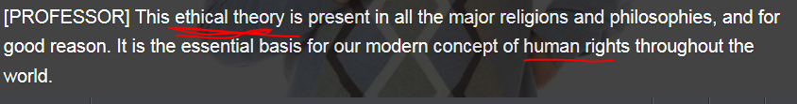

2.N-**PLURAL** Someone's **ethics** are the moral principles about right and wrong behaviour that they believe in. 行为准则 e.g. He told the police that he had thought honestly about the ethics of what he was doing.考虑过他所作所为依据的 **行为准则**。

3.N Ethics is the study of questions about what is morally right and wrong. 伦理学 e.g. ...the teaching of ethics and moral philosophy. …伦理学和道德哲学的教学。

4.N-SING An ethic is an idea or **moral belief** that influences the behaviour, attitudes, and philosophy of a group of people. 道德观念 **[ the ethic of public service 公共服务的道德观念； the working ethic 工作的道德观念 ]** “In each nation, she will emphasize Africa as a place of opportunity, built on the ethic of responsibility,”

非洲是建立在 道德责任 基础上的机会之地。

5) adj) ethical = moral **[ ethical theory 道德理论; ethical dilemma ]** => **unethical, unethically = immoral, immorally**  **[ ethical dilemma /dəˈlɛmə or daɪ-/道德上的左右为难/难以抉择 ]** A dilemma is a difficult situation in which you have to choose between two or more alternatives. 进退两难/左右为难的局面  
e.g. **Ethical** **philosophers** often **come up with** **hypothetical situations** to test their “ethical theories”. These situations are commonly called “**ethical dilemmas**”. One of the most famous “**ethical dilemma**” tests **utilitarian** ethics and is called the “trolley problem”.　　　 //trolley car = tram 有轨电车

**6) [道德健全的: Sth is ethically sound]; [道德上不能容忍的 ethically intolerable xxx]; [道德上有问题的 ethically questionable ]**

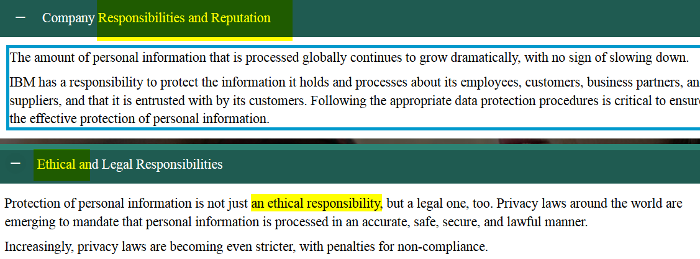

* **amoral** /eɪˈmɒrəl/ If you describe sb (esp a journalist) as amoral, you do not like the way they behave because they do not seem to care whether what they do is right or wrong. 不辨是非的(表不满) **[ an amoral journalist: 不辨是非的记者 ]**e.g. An **emoal journalist** will libel or slander someone just to make headlines.   
  E.g I strongly disagree with this **amoral approach** to politics. 我强烈不同意这种对政治采取 **不辨是非的** 的态度

**V.S. unethical, unethically = immoral, immorally**

* retention /**rɪˈtɛnʃən**/

[N-UNCOUNT](javascript:;)The retention of something is the keeping of it. 保留

•  The Citizens' Forum supported special powers for Quebec but also argued for the retention of a strong central government.   
 《市民论坛》支持魁北克的特殊权力，但是也主张保留一个强有力的中央政府

•The UN will vote on the retention of sanctions against Iraq. 联合国将投票决定是否继续制裁伊拉克。

2.technical) **retention**: is the ability or tendency of something to hold liquid, heat etc within itself〔液体的〕潴留；〔热量等的〕滞留

e.g. To **have sth like pipes or cylinders lagged** **给〔水管等〕加上防冻[保温]层** is to cover water pipes/cylinders with a special material or coating to prevent the water inside them from freezing or prevent the heat from being lost, in other words, **liquid retention** or **heat retention** is kept😊

**•We’ve had the hot-water tank lagged. 我们已给热水箱加上了保温外罩**

•Many people with heart problems suffer from fluid retention. 很多有心脏病的人都有体液潴留。

3. retention: is the ability to keep something in your memory 记忆力

•I have a real problem with retention of information. 我的记忆力大有问题

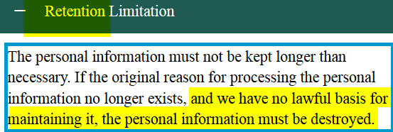

* utilitarianism PK humanism

|  |  |
| --- | --- |
| * utility => utilitarian /juːˌ**tɪ**lɪˈtɛərɪən/ /juːˌ**tai**lɪˈtɛərɪən/   1.ADJ utility => Utilitarian objects and buildings are designed to be useful rather than attractive. (物体、建筑等) 实用的  e,g, Bruce's office is **utilitarian**. 办公室 **实用**   * 2.ADJ Utilitarian means based on the idea that the morally correct course of action is the one that produces benefit for the greatest number of people but hurt benefits or dignity of minorities. **(对大多数人是有益的)**功利主义的 ; e.g. It was James Mill who was the best publicist for **utilitarian** ideas on government. 是政府　**功利主义**思想的最佳宣传家。 e.g. Efficiency, therefore, can never serve as a **utilitarian touchstone(功利主义标准**) for law or for public polics 效率绝不能作为法律或公共政策的功利主义标准   3.N) A utilitarian is someone with utilitarian views. 功利主义者 e.g. One of the greatest utilitarians was Claude. 最伟大的功利主义者之一是克劳德   * utilitarianism /juːˌ**tɪlɪ**ˈtɛərɪəˌnɪzəm/ ; /juːˌ**tai**lɪˈtɛərɪən/    Utilitarianism is the idea that the morally correct course of action is the one that produces benefit for the greatest number of people, hurting benefits or dignity of minorities. **(对大多数人是有益的)**功利主义 | * humanism /ˈhjuː**məˌ**nɪzəm/; humanist  ['hjʊ**mə**nɪst]; humanistic [ care, psychology]   1.N) Humanism is the belief that people can achieve happiness, **[health and well-being 健康，幸福康乐]** and live well without religion. **(没有宗教信仰也可以活的很幸福, 人人有平等的利益／权益的 ) 人文主义 (和宗教价值观一般是相去甚远)**  e.g. We claim to believe what God says about marriage and family, yet our speech patterns are just as likely to reflect feminism女权, humanism人文, and hedonism享乐主义.    2.N) (**(没有宗教信仰也可以活的很幸福 )** 人文主义者 humanist ['hjʊ**mə**nɪst]  e.g. He is a practical humanist, who believes in the **dignity of mankind**.他是个真正的 **人文主义者**。  3. humanistic /ˈhjuːməˌnɪstɪs/ 人文主义的 1.ADJ A humanistic idea, condition, or practice relates to humanism. 人文主义的 e.g. Religious values can often differ greatly from **humanistic morals.** **宗教价值观** 常常和 **人文主义道德观** 相去甚远  V.S.  humanitarian /hjuːˌmænɪˈtɛərɪən/  人道主义的 **[ humanitarian help/assistance 人道主义援助 ]** If a person or society has humanitarian ideas or behaviour, they try to avoid making people suffer or they help people who are suffering; help them out. e.g. Air bombardment raised criticism on the humanitarian grounds that innocent civilians might suffer 因为从人道主义的角度来看，无辜的平民可能会遭受伤害 |

* hedonist /ˈhiːd**ə**nɪst/ 快乐主义者；享乐主义者adj. 享乐主义者的; hedonism/ˈhiː**də**ˌnɪzəm/ 享乐主义
* hedonist is sb. who believes that having pleasure and happiness and enjoying your life at the current moment is the most important thing in life. 享乐主义者
* hedonism /ˈhiːdəˌnɪzəm/:  Hedonism is the belief that gaining pleasure is the most important thing in life. 享乐主义   
  e.g**. the life of hedonism** that she **embraced** in her youth. …她年轻时所 **奉行** 的 **享乐主义生活**。  
  e.g. We claim to believe what God says about marriage and family, yet our speech patterns are just as likely to reflect feminism女权, humanism人文, and hedonism享乐主义.
* **Carpe diem:** enjoy the pleasures **of the moment**, without concern for the future 及时行乐 V.S. hedonist: 享乐主义者
* (无私的) 利他主义altruism /ˈæltruːˌɪzəm/： Altruism is **unselfish** concern and consideration for other people's happiness, welfare, **[ health and well-being健康，幸福安康]**   
  e.g. Fortunately, volunteers are not motivated by self-interest, but by altruism. 志愿者们不是被自身利益而是被利他主义推动
  + **altruistic [,æltru'stik], altruistically [,æltru'stikəli]** If your behaviour or motives are altruistic, you show concern for the happiness and welfare of other people rather than for yourself. 利他的(无私的)
  + **altruist ['æltruist]: 无私者，利他者** someone who makes charitable donations intended to increase human well-being
* egality [i'ɡæliti] n. 均等；平等（等于equality） social and political equality
  + egalitarianism /ɪˌɡælɪˈtɛərɪənɪzəm/:  is used to refer to the belief that all people are equal and should have the same rights and opportunities, and to actions that are based on this belief. 平等主义
  + egalitarian: /ɪˌɡælɪˈtɛərɪən/

1. ADJ Egalitarian means supporting or following the idea that all people are equal and should have the same rights and opportunities. 平等主义的 e.g. I still believe in the notion of an egalitarian society.　我仍然相信平等主义社会的理念。
2. **N) 平等主义者**

* elite /ɪˈliːt, eɪ-/

1.N You can refer to the most powerful, rich, or talented people within a particular group, place, or society as the elite. 精英 e.g. ...a government comprised mainly of the elite. …主要由精英组成的政府。

2.ADJ Elite people or organizations are considered to be the best of their kind. 精英的 e.g. ...the elite troops of the president's bodyguard.…总统卫队中的精英部队。

* + elitism /ɪˈliːtɪzəm/ or  [ei'li:tizəm] => elitist  /ɪˈliːtɪst, e’liːtɪs/

Elitism is the quality or practice of being elitist. 精英主义 e.g. It became difficult to promote conventional ideas of excellence without being instantly accused of **elitism**. 倡议传统优秀价值观，很难不立刻招来 **精英主义** 的指责。

E.g. For luxury fashion brands that pride themselves on **elitism** and inaccessibility, this may be the most difficult challenge in developing a social media strategy.  对于那些对自身的 **精英主义** 和高高在上引以为傲的时尚奢侈品牌来说

* + elitist /ɪˈliːtɪst, e’liːtɪs/

1.ADJ Elitist systems, practices, or ideas favour the most powerful, rich, or talented people within a group, place, or society. 精英主义的(表不满) [ 精英主义的教育 elitist education ] e.g. He worries about a time when college athletics become even more **elitist** than they are now. 他担心有一天大学体育运动会变得比现在更加精英主义化。

2.N An elitist is someone who has elitist ideas or is part of an elite. 精英主义者(表不满) e.g. He was an elitist who had no time for the masses. 他是个精英主义者，没时间给民众。

* **idealism /aɪˈdɪəˌlɪzəm/**

1.N) Idealism is the beliefs and behaviour of someone who has ideals and who tries to base their behaviour on these ideals. 理想主义 e.g. She never lost her respect for the idealism of the 1960s.

她从未摈弃自己对20世纪60年代理想主义的崇敬。

2.N）理想主义者 idealist [aɪ'dɪəlɪst] e.g. He is not such an **idealist** that he cannot see the problems. 他不是一个看不见问题的理想主义者

* 道德争议**moral controversy**

e.g There’s plenty of/a heck of/tons of/loads of  **moral controversy**, to be sure. But there’s also a lot of moral agreement.  生活中充满了 **道德争议**，然而道德一致性也随处可见。

e.g. XXX have stressed the **importance of the ethical** and moral aspects of the controversy

强调道德的重要性和这件事在道德方面所引起的争议。

**//moral, morality V.S. mortal ( a mortal human凡人); mortality rate/death rate; immortal words/lines不朽(不会死的)的名言； (不会死的)神仙**

## mp3 done) video

What’s right? What’s wrong? How do we decide?





 [,ju:tili'tεəriənizəm] 功利主义的；实利的 ; hedonist: 快乐主义者；享乐主义者  ['hidənɪst]











* Utilitarian （功利主义者；实用主义者 ）: in favor of death penalties

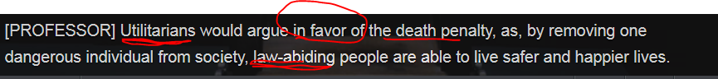



* Humanist ['hjʊmənɪst]人文主义者: oppose death penalties









 abolish/repeal a law  废除；废止(法令)





endearing /ɪnˈdɪərɪŋ/  If you describe someone's behaviour as endearing, you mean that it causes you to **feel very fond of** them, like it very much. 惹人喜爱的/招人喜爱的

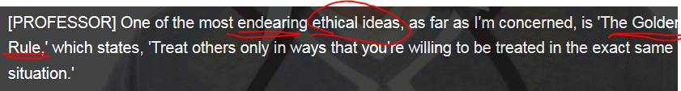

**己所不欲，勿施于人: The golden rule states “treat others only in ways that you’re willing to be treated in the exact same situation’.**



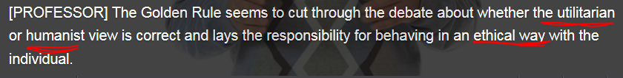



## Systems of belief

* Use the suffix **-ism** for words that refer to a school of **philosophy** or a system of **beliefs**.
* Use the suffix **-ist** for words that refer to a **person** who belongs to a particular school of **philosophy** or **belief**.

|  |  |
| --- | --- |
| Use the suffix **-ism** for words that refer to a school of **philosophy** or a system of **beliefs**. | a **person** who belongs to a particular school of **philosophy** or **belief**. |
| **Hedonism** refers to a belief that only what causes pleasure is good.  Carpe diem: enjoy the pleasures **of the moment**, without concern for the future 及时行乐 | Martin is a **hedonist**. |
| **Utilitarianism** is a belief that what is useful for the largest number of people is good. | Martin is a **utilitarian** |
| **Humanism** is a system of thought that focuses on the needs and worth of human beings | **humanist** => humanistic |
| **Altruism** is unselfishness, or a great concern for the welfare of others.  altruism /ˈæltruːˌɪzəm/： Altruism is unselfish concern for other people's happiness and welfare. 利他主义(无私的) ;  altruistic /ˈæltruːˌɪstɪk/ If your behaviour or motives are altruistic, you show concern for the happiness and welfare of other people rather than for yourself. 利他的(无私的) | altruist ['æltruist]: someone who makes charitable donations intended to increase human well-being  I am very happy to see such **altruistic** behavior from young people these days |
| **egality, egalitarianism** is a belief that all people should have equal political and social rights. ( is used to refer to the belief that all people are equal and should have the same rights and opportunities, and to actions that are based on this belief. 平等主义) | egalitarian: /ɪˌɡælɪˈtɛərɪən/   1. ADJ 平等主义的 2. N) 平等主义者 |
| **Elite, elitism** is the belief that some people are better than others and should have more rights.  (elite => elitism, elitist : Elitism is the quality or practice of being elitist. 精英主义) | * elitist /ɪˈliːtɪst, e’liːtɪs/   1.ADJ Elitist systems, practices, or ideas favour the most powerful, rich, or talented people within a group, place, or society. 精英主义的(表不满) [ 精英主义的教育 elitist education ]  2.N An elitist is someone who has elitist ideas or is part of an elite. 精英主义者( 表不满) |
| **Idealism** is the idea that you have to follow your beliefs even when they conflict with society. |  |

## 2nd row) **Refuting/overthrow an argument**

|  |  |
| --- | --- |
| 驳倒/推翻（论点/证据/证词/控诉/谣言） | 驳倒论据/证词／谣言／对某人的指控 talk down/overthrow/refute/topple down/demolish (arguments/testimonies/rumor/accusation against sb.): you prove that they are completely wrong or unreasonable with solid evidence. |
| refute /rɪˈfjuːt/  1. V-T If you refute an argument, accusation, or theory, you prove that it is wrong or untrue. 驳倒 refute sth: tprove sth to be false/erroneous with solid evidence => overthrow/refute/topple down/demolish/ talk down (sb's idea, arguments, testimony, rumor, accusation against sb) [ refute/demolish/overthrow/talk down/topple down the argument; 驳倒/推翻证据: refute/overthrow/demolish/talk down/topple down the evidence; 驳倒/推翻证词: refute/overthrow/demolish/talk down/topple down the testimony; 驳倒/推翻对某人的控诉: refute/overthrow/demolish/talk down/topple down the accusation against sb.; 驳倒/推翻谣言: refute/overthrow/topple down/talk down the scandal）  eg The defence lawyers refuted/overthrew the testimony by having a resort/recourse凭借于借助于 to solid evidences in court.  2. V-T 予以否认 refute sth: not acknowledge, but to deny or veto the accuracy or truth of sth [不承认选举结果的真实性 refute the authenticity of the poll] |
| overthrow = topple down (overthrowing,overthrew,overthrown,overthrows) 1. V-T When a government, a leader, an authoritarian system, or an autocrat is overthrown/toppled down, they are removed from power by force. (政府，领导人，独裁统治者）被颠覆/被推翻 e.g. That government was overthrown/toppled down in a military coup three years ago. 该政府在3年前的一次军事政变中被颠覆了。  2. N-SING Overthrow is also a noun. 颠覆 e.g. Insurgents erupted a military coup and wanna overthrow/topple down the top autocrat in the current goverment. However, the coup is foiled/thwarted; and they were charged with plotting the overthrow of the state. 颠覆国家 e.g. Its last monarch, Shah, was overthrown/toppled down in 1979, but he was replaced by yet another autocrat, the Ayatollah, who is critically tyrannical.  e.g. In ancient China, Qing emperor in Qin Dynasty is one of the most notorious/disreputable dictators/autocrats/authoritrians, which was finally overthrown/toppled down by insurgents.  e.g. Insurgents are people who are fighting against the government or army of their own country, in order to **overthrow/topple down** the current government. 起义者  //臭名昭著的: notorious = disreputable  // A tyranny/ˈtɪrənɪ/ 专制暴政, tyrannical /tɪˈrænɪkəl/;  // 独裁者 **autocrat** /ˈɔːtəˌkræt/, autocratic /ˌɔːtəˈkrætɪk/, autocratically, authoritarian |
| topple down  sth | topple down sth   1. 使xxx倒塌; e.g. To further women's development, we must **topple down** **sexism/chauvinism ['ʃəʊv(ɪ)nɪz(ə)m]男性至上主义** and reconstruct the International political and economic framework in the spirit of gender equality and **abolish/repeal(废除，废止)** gender discrimination. 2. 颠覆xxx(传统; 老套): topple down conventional ways; topple down the stereotypes; topple down the mainstream society 颠覆主流社会 3. topple down sb’s arguments = refute/overthrow sb’s argument驳倒/推翻（论点/证据/证词/控诉/谣言） |
| **把一个(论点/证词)驳得体无完肤** | **tear sth to shreds**  [ 把一个(论点)驳得体无完肤: tear an argument to shreds; 把一个(证词)驳得体无完肤: tear the testimony to shreds ] //碎纸机 paper shredder |

Often when you are discussing a controversial topic, someone will say something that you **strongly disagree with**. Use these phrases to reject or **refute/overthrow** the person's **argument**.

* **I beg to differ 恕我不能赞同; 恕我不敢苟同**e.g. You may think that football is better to watch than cricket板球, but **no offense Sir/with all my respects Sir(毫无冒犯之意),** I **beg to differ.** **本人不敢苟同**
* **That's simply not true.**
* I think you're mistaken.
* **That's a fallacy** ( an obvious mistake **['fæləsi] 谬论，谬误. )**
* **That's just not the case.**
* I don't think that's right.
* That's absolutely untrue.

## 3rd row) Modal auxiliary verbs (形式辅助动词)

**Modal auxiliary verbs : can, should, must, might, maybe, will, ought to, needn’t**

It is possible for **modal verbs** to carry more than one meaning, and that meaning can change depending on the situation. Read the sentences then choose the two summaries that correctly describe their possible meaning.

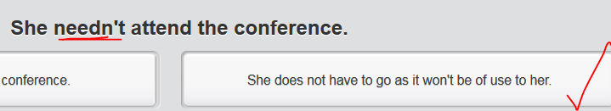

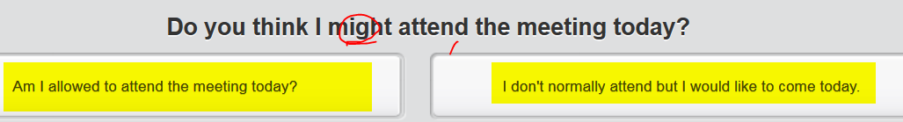

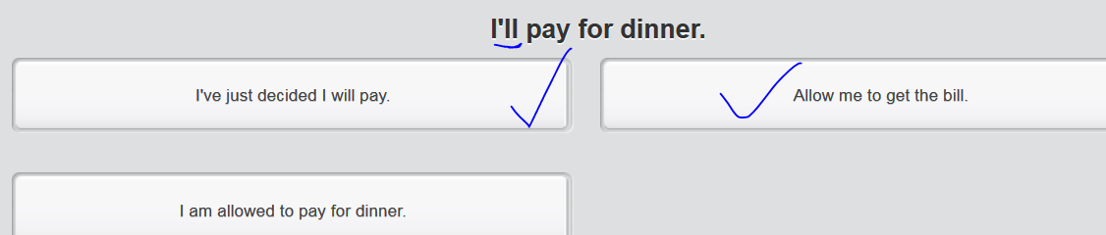

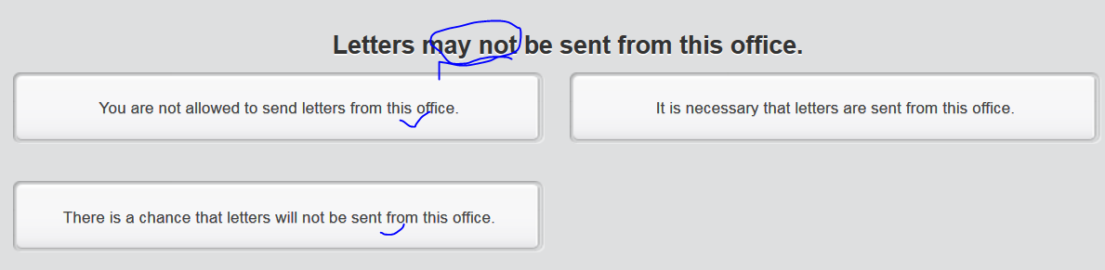

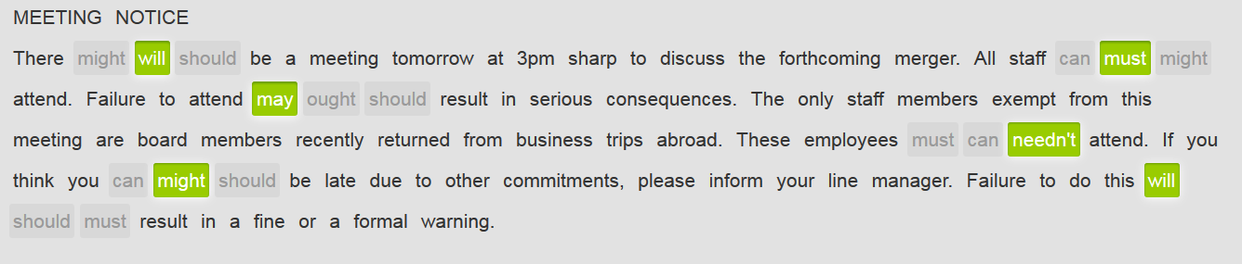

## Done mp3)

## 4th row) Attending a talk on civil disobedience(**(非暴力, 但不合作运动)**

You are talking with your friend Sally about a lecture that she attended. Ask her for details and then give your opinion. => **think about HK “civil disobedience” activity that occupies “Central HK” during HK’s universal suffrage**

## Stop* Not mp3) video

# Part 2)

## Lexical resource

* [dəˈlɛmə or d**aɪ**-] **[ ethical dilemma: 道德上的左右为难/难以抉择 ]** A dilemma is a difficult situation in which you have to choose between two or more alternatives. 进退两难/左右为难的局面  
  e.g. He was faced with the dilemma of whether or not to return to his country. 他面临着是否回国的艰难选择。  
  e.g. **Ethical** philosophers often **come up with** **hypothetical situations** to test their “ethical theories”. These situations are commonly called “**ethical dilemmas**”. One of the most famous “**ethical dilemma**” tests **utilitarian** ethics and is called the “trolley problem”.
* 买者empt**or** ['emptə]: a person who buys, **emptor =**[**buyer**](javascript:void(0);)**/**[**purchaser**](javascript:void(0);)**/**[**vendee**](javascript:void(0);)
* As a matter of a fact = in fact = actually
* 减税 **tax break**N) If the government gives **a tax break** to a particular group of people or type of organization, it reduces the amount of tax they have to pay or changes the tax system in a way that benefits them.   
  e.g. Today they'll consider **tax breaks** for businesses that create jobs in inner cities.  
  **V.S.   
  [ n] tax dodge/avoidance/evasion: 逃税避税; v) dodge/avoid/evade tax ]**
* **突出/强调xxx** accentuate [**ə**k'sɛntʃueɪt] /**æ**kˈsɛntʃʊˌeɪt/; **accentuate sth=**[**emphasize**](javascript:void(0);)**/** [**stress**](javascript:void(0);)**/**[**highlight**](javascript:void(0);) **= make sth noticeable ;** V-T To accentuate something means to emphasize it or make it more **noticeable**. 使突出   
  e.g. His shaven head **accentuates** his large round fat face. 他剃了的光头 **突出了** 他的大圆脸。   
  E.g. The lighting wall serves to **accentuate** the nature of the material 是用来 **强调** 材料的自然性
* hypothesis /haɪˈpɒθɪsɪs/    
  A hypothesis is an idea which is suggested as a possible explanation for a particular situation or condition, but which has not yet been proved to be correct. 假设 (assumption, untrue situation ) e.g. Work will now begin to test the hypothesis in rats. 在老鼠身上验证这一假设的工作现在要开始了
* hypothetical /ˌhaɪpəˈθɛtɪkəl/ ; hypothetically [,haɪpə'θɛtɪkli]: If something is hypothetical, it is based on possible ideas or situations rather than actual ones. **假设的 [ hypothetical situation = un untrue situation ]** e.g. Let's look at a **hypothetical situation** in which Carol, a recovering alcoholic, gets invited to a party. 我们来假设一下这样一个情;
* 以假设方式 hypothetically e.g. He was invariably willing to discuss the possibilities hypothetically. 他总是愿意以假设方式讨论各种可能性

e.g. **Ethical** **philosophers** often **come up with** **[ hypothetical situations ]** to test their “ethical theories”. These situations are commonly called “**ethical dilemmas**”. One of the most famous “**ethical dilemma**” tests **utilitarian** ethics and is called the “trolley problem”.　 //a trolley car = tram 有轨电车

* trolley /ˈtrɒlɪ/     
  1.N)  A **trolley** or **[a trolley car/tram]** is an electric vehicle for carrying people which travels on rails in the streets of a city or town. 有轨电车 V.S. A **tram** is a public transportation vehicle, usually powered by electricity from wires above it, which travels along rails laid in the surface of a street. 有轨电车 e.g.He took a **northbound trolley有轨电车** on State Street. 坐上了一辆 北行的 有轨电车。  
  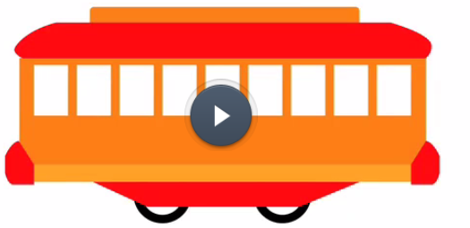

2.N) A trolley is an object with wheels that you use to transport heavy things such as shopping or luggage. **(supermarket)手推车**   
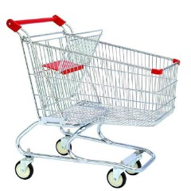

3.N) A trolley is a small table on wheels which is used for serving drinks or food. (送饮料或食品的) 小车   
VS. A **dolly** is a low cart with wheels that is used for moving **heavy objects,** for example, in a factory. (工厂里面的)搬运车

4.N) A **trolley/gurney** is a bed on wheels for moving patients in a hospital. (医院用的) 担架车e.g. A man on a trolley was being handled by an orderly. 一个轮床上的男子正由一个护理员推送

=> a trolley = a gurney /ˈɡɜːnɪ/ A **gurney** is a bed on wheels that is used in hospitals for moving sick or injured people. (医院用的) 担架车, 有轮的病床  
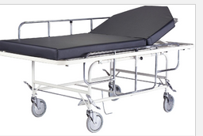( trolley/gurney) 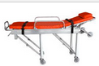(stretcher)  
=> A **stretcher** is a long piece of canvas with a pole along each side, which is used to carry an injured or sick person. 担架

* dolly /ˈdɒlɪ/   
  N) A dolly is a child's word for a doll. [ literal ] 洋娃娃；玩偶   
   **[figurative meaning ]无头脑的美丽女人**N) A dolly is a low cart with wheels that is used for moving heavy objects, for example, in a factory. (工厂里面的)搬运车 e.g. ...dozens of vendors pushing dollies that are stacked high with boxes. ...很多推着高高地累满箱子的搬运车的小贩
* A junction is a place where roads or **railway lines** join. (铁路线、公路的) 汇合点 [ **a junction (on the train track); a junction switch ]**   
  e.g. In xujiahui, there is a famous **junction** where five small roads join. 五条道路的　**汇合点**

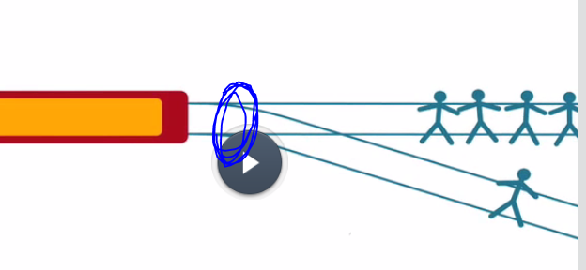 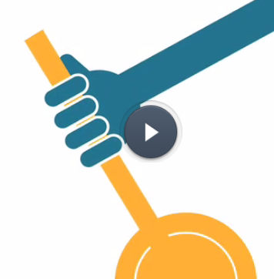

* What if ? = what would you do if?
* pros and cons = benefits and **drawbacks**
* instinct /ˈɪnstɪŋkt/

1. Instinct is the **natural tendency** that a person or animal has to behave or react in a particular way. 本能 [**母性本能 maternal instinct ]** e.g. I didn't have as strong **a maternal instinct** as some other mothers. 我不像其他一些母亲那样有那么强烈的 **母性本能**。

2. **在<xxx 方面>有天分天赋**If you **[ have an instinct for sth = have talents ],** you are **naturally** good at it or able to do it, having talent 天分天赋/ => Talent is the **natural** ability to do something well. 天赋   
e.g. He seems to **have an instinct for** smart advertising and marketing. 他在广告方面 有**天分天赋**。 E.g. She seems to **have an instinct for** business. 他好像在做生意上有**天分天赋**

3.N If it is your instinct to do something, you feel that it is natural and right to do it. 本能的反应 **[ 我的本能反应my first instinct V.S. 第二天性， 第二本能 my second nature ]** e.g. I should've gone with my **first instinct**, which was not to do the interview. 我应该凭我的本能反应行事，那就是，不去面试。

4.N Instinct is a **gut feeling or emotional feeling**, rather than an opinion or idea based on facts, that something is the case. 直觉 **[ instinct = gut, e.g. I have a gut feeling that xxx 我的直觉是]** e.g. There is scientific evidence to support our instinct that being surrounded by plants is good for health. 有科学证据表明我们的直觉是正确的

* gut

|  |
| --- |
| [复]内脏, A person's or animal's guts are all the organs inside them. 内脏 **[ fish guts鱼内脏 ]** |
| The gut is the tube inside the body of a person or animal through which food passes while it is being digested. 肠 (幽门到直肠间的)肠子 **(gut = intestine; colon, colonic, colon cancer结肠)** |
| **Guts** is the will and courage to do something that is difficult or unpleasant, or which might have unpleasant results. 勇气胆量 **[ guts/courage/boldness/bravery; have the guts/bravery to do sth 有胆量做xxx; No guts! 没胆量 ]** e.g. The new governor **has the guts** to push through unpopular tax increases. 新任州长 **有胆量** 强制通过不得人心的增税方案通过。 |
| A **gut feeling** is based on **instinct** or emotion rather than reason. 直觉的 **[ 我有一个直觉　I have a gut feeling that = I have an instinct/intuition that; 我的直觉在告诉我My intuition/gut/instinct was telling that xxx ]**  e.g. **My gut/intuition/instinct says No** and I believe you didn't **commit a misconduct/adultery**; however, we're **not a shred of evidence** to proof that you're innocent 丝毫没有证据  e.g. **I have a gut feeling that/I have an instinct that**  DP project will sunset soon and most of us will be fired. |
| If you **hate someone's guts,** you dislike them very much. 对某人恨之入骨 e.g. We **hate each other's guts**. 我们对彼此恨之入骨 |
| 拼命工作 If you say that **you are working your guts out,** you are emphasizing that you are working as hard as you can. e.g. Most have **worked their guts out** and made sacrifices. 大多数人都拼命工作并做出了牺牲 e.g. In DP, almost everyone is **working their guts out.** E.g. I'm **working my guts out** to earn money |

* intuition /ˌɪntjʊˈɪʃən/ Your intuition or your intuitions are unexplained feelings that something is true even when you have no evidence or proof of it.   
  E.g. **Her intuition/gut/instinct was telling her that** something was wrong. 她的直觉在告诉xxx  
  e.g. **Her gut/instinct/intuition was telling her** that DP project will end its life maybe soon because of exodus of clients, esp. with the desperately sluggish economy. However, **I beg to differ (恕我不能赞同; 恕我不敢苟同 )**eg **Rules of thumb**, or heuristics, can assist you in making good decisions in situations that defy/challenge statistical analysis. People use rules of thumb/heuristics consciously and unconsciously. When used unconsciously, rules of thumb or heuristics result in judgments that are actually based on intuition. Conscious calculation may be sufficient in situations with known risks, but in situations with unknown risks, “**intuition/gut/instinct** is indispensable (absolutely essential and vital 不可缺少的；绝对必要的).”

## 1st) row Decision-making

## done mp3) video

 [dəˈlɛmə or d**aɪ-] [ ethical dilemma: 道德上的左右为难/难以抉择 ]**





//a trolley car = a tram; A junction is a place where roads or railway lines join. (铁路线、公路的) 汇合点

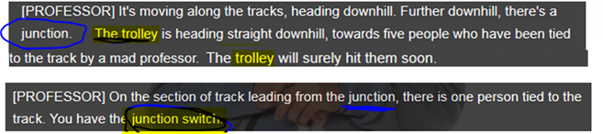

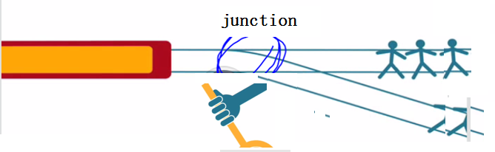







 what would you do for this **[ethical dilemma]**?



## How to make decisions?

Read about how Paolo and Rachel make decisions and answer the questions that follow.

What does Rachel mean when she says, **'I think with my head and not my heart'**? = she makes **rational rather than emotional decision.**

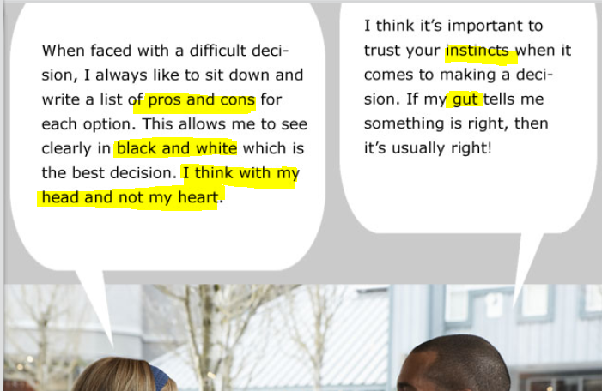

## Reading –A decision-making matrix

When faced with making a difficult decision, it is helpful to **break the process down into a series of stages**.

**First**, specify your requirements – write a list of exactly what you need and why.

**Next**, prioritize these criteria – which is the most important requirement and which could you work around if necessary.

Then identify a number of possible solutions. Compare these solutions by rating the alternatives according to your criteria.

**Consider the consequences** or **assess the risks** associated with each. (A decision-making matrix can work **out** these calculations for you, should you require.)

**Finally**, the best decision should become obvious.

## A decision-making matrix (e.g..to buy a house)

|  |  |  |
| --- | --- | --- |
| Requirements | Required/Optional? | Priority |
| R1: Education |  | M |
| R2: Metro (transportation) |  | H |
| R3: Green env (air pollution) |  | M |
| R4: Hospital, crimes, |  | L |

|  |  |  |  |  |
| --- | --- | --- | --- | --- |
| Solution | Pros (benefits) | Cons (**drawbacks**) | Consider the consequences/assess risks | Rating |
|  |  |  |  |  |
|  |  |  |  |  |

## done mp3) video: decision making



## 2nd row) Stressing a point in an argument

In a discussion, you will sometimes want to stress a particular point. Use these expressions to restate or emphasize your point:

* **To reiterate my point,** I think that capital punishment is immoral.
* **Let me emphasize/accentuate this point.** You need to find a job that pays better.
* **Allow me to draw your attention to this point.** Capital Finance, Inc. treats its employees well.
* **I'd like to accentuate/emphasize/highlight** **this point.** Your current job is making you very unhappy.
* **I'd like to stress that** you're still young enough to change careers.
* **I'd like to stress that** I fully support the idea.
* **突出/强调xxx** accentuate /ək'sɛntʃuet]/ /ækˈsɛntʃʊˌeɪt/ sth = [emphasize](javascript:void(0);) / [stress](javascript:void(0);) / [highlight](javascript:void(0);) = make sth noticeable ; V-T To accentuate something means to emphasize it or make it more **noticeable**. 使突出   
  e.g. His shaven head **accentuates** his large round face. 他剃了的光头**突出了**他的大圆脸。   
  E.g. The lighting wall serves to accentuate the nature of the material 是用来 **强调** 材料的自然性

## done mp3) video: stress your points/arguments



## 3rd row) Showing contrast (comparison and contrast)

**See unit “education and training” > comparison by using the Venn Diagram**

|  |  |
| --- | --- |
| **Contrast** | **Addition** |
| * On the contrary, xxx 相反… * In **stark** contrast to sth, 与…形成(鲜明的)对比 * …**whereas**, xxx * **…nevertheless, xxx (然而，尽管如此)** * **nonetheless /ˌnʌnðəˈlɛs/尽管如此**  e.g. There was still a long way to go. **Nonetheless**, some progress had been made. 尽管如此, 还是取得了一些进步 * … actually, * On the one hand, xxxx… on the other hand | * On top of that (additionally) * **Furthermore = moreover = in addition = additionally**: used to introduce a piece of information or opinion that adds to or supports the previous one. 此外 * besides |

I asked her why she never ate fruit. she replied, '' **Actually**, I much prefer vegetables.'

**On the one hand,** I agree with many of the new minister's policies. **On the other hand,** I don't trust him one little bit.

I had failed to deliver my project on time. **In addition/additionally/furthermore/Moreover**, the prototype had a number of serious problems. My boss was not at all happy.

The reporter accused her of making up the story and pretending it was true. **'On the contrary** , every word is true,' the writer replied.

The liberal politician believes in free healthcare and education, **while** her conservative opponent believes in tax breaks for new businesses.

It had been raining all day. Nevertheless**/nonetheless尽管如此**, we decided to play the soccer match.

e.g.

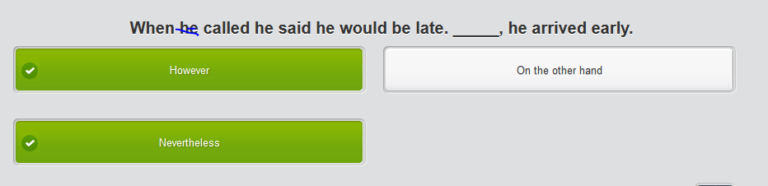

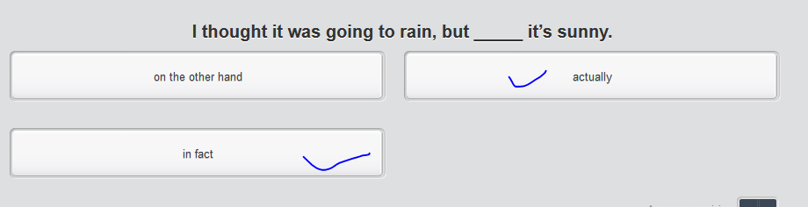

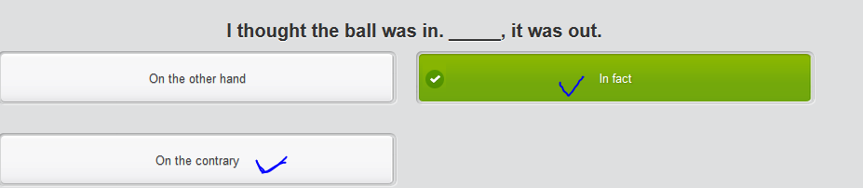

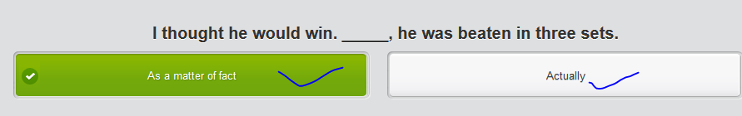

**Venn Diagram**

|  |  |  |
| --- | --- | --- |
| Properties of object | Object A (bachelor’s) | Object B ( master’s) |
| Duration | 4 yrs | 2-3 yrs |
| Tuition |  |  |
| Type of instruction | Lecture (hosted by professors) | Seminar |
|  |  |  |

## 4th row) Reaching a decision

You are talking to a good friend who has been offered a new job by Emptor, Inc. He is having trouble **deciding whether to** take the new job. Help him make his decision.

## Not done) Mp3

* Hi Man, I just cannot decide. I’ve been working in IBM for 10yrs, but I got an offer from MS as an **emptor/buyer/purchaser**. I’m kind of scared to leave.



* What would I want? Do you mean what’s the most important thing for me to choose a company?
* Compensation, of course, is the key requirement. I’d like to earn more money. However, **there’s more than that.** My current job is really secure and boring. I’m just sitting in my desk and staring at the computer all day. I’m just a junior accountant.



* Well, I’m talking to accountants and managers to help design new accounting software.

Sounds good. But any other important things to you?

* Security is so important now that kid’s working. I have lots of **savings存款** coz my wife has a pretty good job. I guess what I want is a little adventurous job that allows me to be more **interactive** with people, less **interaction** with my computer. **Let me emphasize/reiterate that** I would like to earn more money.



* That’s obvious. If I took the job as an **emptor/buyer/purchaser**, I will travel all over the year, meet and interact with clients, get ideas to improve our software. And I like the woman who’s going to be my manager. But it’s just a startup, she can be boss anytime.



* I understand, I don’t feel pressured, but just a little upset. Talking to you very helpful, I’m not going to make the decision now, but you help to **comb my logic梳理**. I’m close to deciding. Thanks a lot.



# Part 3) Attend a talk in civil disobedience (非暴力, 但不合作运动)

## 1st row) How to react to morally wrong social issues such as racial segregation - by civil disobedience

## Lexical resource

* (natural disaster) 对xxx 肆虐 wreak havoc (on sth )

e.g. Solar storms could **wreak havoc on** satellites and **power grids**, and so scientists have humbly turned to netizens across the world to help watch our sun for possible signs of such storms.  
  
e.g. The world's **treacherous /ˈtrɛtʃərəs/ (危险的; 变化莫测的) weather** with devastating **blizzard**暴风雪 and tornadoes/twsters **wreaked havoc** across the globe. **Torrential rains** in parts of South America, blamed/shattered on El Nino, have **displaced转移 more than 150K people**. In the U.S., a **mammoth storm** system **engulfing/devouring吞食** much of the country has claimed at least 24 lives, including four soldiers in Missouri.

* harass sb. /ˈhærəs, həˈræs/

1.V-T If someone harasses you, they trouble or annoy you, for example by attacking you repeatedly or by causing you as many problems as they can. 骚扰 e.g. A woman reporter complained one of them sexually harassed her in the locker room. **性骚扰 [ harass sb. sexually = molest sb sexually /məˈlɛst/]**

harassment /ˈhəræsmənt, ˈhærəs-/: Harassment is behaviour which is intended to trouble or annoy someone, for example repeated attacks on them or attempts to cause them problems. 骚扰 **[ sexual harassment 性骚扰 = molest sb sexually ]**

e.g. Another survey found that 51 percent of women had experienced some form of **sexual harassment** in their working lives. 某种形式的 性骚扰

* **molest (a woman or a child)**  /məˈlɛst/ = harass sb. sexually:  A person who molests someone**, especially a woman or a child**, interferes with them **in a sexual way** against their will. 对…性骚扰 (尤指妇女或孩子) e.g. He was accused of sexually **molesting/harass** a female colleague. 他被指控对一名女同事进行性骚扰
* If things **abound**, or if a place **abounds with things**, there are very large numbers of them. 充满
* **在枪口威胁下 gunpoint /ˈɡʌnˌpɔɪnt/ [ at gunpoint ]** If you are held **at gunpoint,** someone is threatening to shoot and kill you if you do not obey them.   
  e.g. She and her two daughters were held **at gunpoint** by a gang who burst into their home. 被一伙闯入家中的歹徒持枪挟持   
  e.g. Two friends of yours were recently robbed **at gunpoint (在枪口威胁下)** in their home.
* **Road rage:** the aggressive behavior demonstrated by drivers often as a result of the actions of other road users. **Road rage** is anger or violent behaviour caused by someone else's bad driving or the stress of being in heavy traffic. （主要是指驾驶人因不耐前车或不满抢道而引起的愤怒）  
  e.g. Two women were being arrested by police after a **road rage** attack on a male motorist
* **取消/取缔（限制/禁令/制裁） lift bans on sth; lift restrictions on sth; lift sanctions against a country**

e.g. It was followed in 1965 by the National Voting Rights Act, which **lifted unhuman restrictions** on African Americans being able to vote.  
e.g. UN. Has **lifted** their draconian economic sanctions against DPRK and the 6-party talk will be resumed.

* **civil disobedience ( 非暴力, 但不合作运动): resist following gov’s order by non-violent and non-cooperative actions, e.g. demonstration, protest, or sit-in**静坐

e.g. The professor calls violence an **ethically questionable** tactic of resistance. 暴力是一种 **道德上有问题**的 **抵御/对抗计策**

e.g. Gandhi's policy was **civil disobedience,** which means not following orders.

e.g. To show opposition against the decision in HK’s **universal suffrage/franchise**, which is said to be controlled by BJ, thousands of HK residents join the **civil disobedience** by **sitting in** around the core hubs in HK. Finally, cops **unleashed** “**pepper spray and tear gas”** to disperse thousands of **sit-in protesters静坐示威者 //催泪弹, 催泪瓦斯 tear gas; //胡椒喷雾剂；防狼喷雾: pepper spray**

e.g. Six months after the end of the massive "Central Occupy" protests in HK- **a civil disobedience**, which **paralyzed**使瘫痪 the city's main streets and almost **brought the whole city traffic into a standstill**, another **pivotal** demonstration against Chinese Communist is **brewing/fermenting酝酿发酵** in the former British colony.   
//使交通瘫痪: bring traffic into standstill = paralyze the traffic

* **[ 种族隔离racial segregation ]** is separating people because of their race or color
* **Cast votes/ballots V.S. suffrage V.S. franchise**

|  |  |
| --- | --- |
| suffrage | The right or privilege of voting/balloting['bælət]; the **franchise.** 投票的权利或特权；投票权; A vote cast in deciding a disputed or controversial question or in electing a person to office. **投的票 [ the universal suffrage/franchise（HK）普选 ]** |
| eg In 2012, China announced that in 2017 Hong Kong could elect its chief executive through "**universal suffrage**". But, the True **universal suffrage** would not have solved all governance problems of what is becoming a more unequal and polarized society. "It is **definitely** better to have the (chief executive) elected in a **universal suffrage** by five million **eligible** voters than by 1,200 people. And it is **definitely** better to **cast your vote/ballot** at the **polling station** than to stay home and watch on television the 1,200 members of the Election Committee cast their votes."  e.g. To show opposition against the decision in HK’s **universal suffrage/franchise**, which is said to be controlled by BJ, thousands of HK residents join the **civil disobedience** by **sitting in** around the core hubs in HK. Finally, cops **unleashed** “**pepper spray and tear gas”** to disperse thousands of **sit-in protesters静坐示威者 //催泪弹, 催泪瓦斯 tear gas; //胡椒喷雾剂；防狼喷雾: pepper spray** |
| franchise | 1. A franchise is an authority that is given by an organization to someone, allowing them to sell its goods or services or to take part in an activity which the organization controls. (公司授予某人的) 特许经营权 **[ fast-food franchises. 快餐特许经营权; the franchise to build and operate the tunnel. …建造、运营隧道的特许权]** 2. V)  If a company **franchises its business**, it sells franchises to other companies, allowing them to sell its goods or services. 出售…的特许经营权 **[ franchise sb’s business ]** e.g. she has recently **franchised her business**. 出售了(其公司的) 特许经营权。 3. N) Franchise is the right to vote in an election. 选举权; The constitutional or statutory right to vote or ballot= suffrage (宪法或法律规定的)**选举权 = suffrage [** the introduction of **universal franchise/suffrage 普选权**的采用 ]   eg In 2012, China announced that in 2017 Hong Kong could elect its chief executive through "**the universal suffrage/franchise普选**". But, the True **universal suffrage/franchise** would not have solved all governance problems of what is becoming a more unequal and polarized society. **[the statue of liberty: 自由女神像； statute ['stætʃut] 法令-> statutory /ˈstætjʊtərɪ/  ]** |
|  | disenfranchise sb /ˌdɪsɪnˈfræntʃaɪz/ (disenfranchising,disenfranchised,disenfranchises)  1.V-T To disenfranchise a group of people means to take away their right to vote or other rights that most other people have. 剥夺 (某人群的) 权利; 剥夺(某人的／公民的)选举权 e.g. ...fears of an organized attempt to **disenfranchise supporters** of Father Aristide. …对 **剥夺支持者选举权** 的一次有组织企图的担心。  Disenfranchisement (n): n. 剥夺公民选举权 e.g. King led the campaign to end **racial segregation** and electoral **disenfranchisement** in the USA. |
|  | * **cast a vote/ballot**   e.g. "It is **definitely** better to have the (chief executive) elected in a **universal suffrage** by five million **eligible** voters than by 1,200 people. And it is **definitely** better to **cast your vote/ballot** at the **polling station** than to stay home and watch on television the 1,200 members of the Election Committee cast their votes.".  e.g. In HK, changing that policy is demand No. 1 for the protesters, who say that having every citizen **cast a vote/ballo**t in an election **(universal suffrage)** is **moot (practically meaningless无实际意义的)**  if the options are already decided in Beijing. |

* **[静坐示威 the sit-in; 静坐的示威者: the sit-in protesters ]**An organized protest demonstration in which participants sit themselves peacefully in an appropriate place and refuse to move; "sit-in" is a classical type of "**civil disobedience 非暴力但不合作运动 (non-violent and non-cooperative actions)"** .

e.g. To show opposition against the decision in HK’s **universal suffrage/franchise**, which is said to be controlled by BJ, thousands of HK residents join the **civil disobedience** by **sitting in** around the core hubs in HK. Finally, cops **unleashed** “**pepper spray and tear gas”** to disperse thousands of **sit-in protesters静坐示威者 //催泪弹, 催泪瓦斯 tear gas; //胡椒喷雾剂；防狼喷雾: pepper spray**

e.g. Six months after the end of the massive "Central Occupy" protests in HK- **a civil disobedience**, which **paralyzed**使瘫痪 the city's main streets and almost **brought the whole city traffic into a standstill**, another **pivotal** demonstration against Chinese Communist is **brewing/fermenting酝酿发酵** in the former British colony.

* 使交通瘫痪: bring traffic into **a** standstill = paralyze the traffic   
  使(电力)瘫痪 **paralyze** the power system; 使(电网)瘫痪 paralyze the **electricity grid**
* 恶意/蓄意破坏sth

|  |  |
| --- | --- |
| 恶意/蓄意破坏（战争中百姓或敌军势力进行的）对财产的破坏或对正常秩序的阻挠 | sabotage sth: maclicious/spiteful/venoed destruction of property or obstruction of normal operations **deliberately**, as by civilians or enemy agents, or insurgents叛乱者/起义者 in time of war; sabotage sth=destroy sth deliberately/intentionally, especially with spiteful or malicious venom, as through acts of vandalism, normally in order to hinder/hamper/impede a project . 暗中破坏/故意捣乱 (为击败或阻碍一项目标或努力而进行的不忠行为；  [对……进行蓄意破坏/阴谋破坏 To commit sabotage/vandalism against; engage in sabotage 从事破坏; sabotage the peace蓄意破坏和平; sabotage an agreement 蓄意破坏协定]  eg In the massacre/holocaust/carnage, The ISIS terrorists not only killed dozes of innocent children, but sabotaged the Muslim mosques - the jewelry of the Muslim history. |
| 蓄意破坏(公共或私人财产), 尤指文化、艺术品的破坏) | vandalize/vandalise, vadalization; vandalism (n): sabotage: the **deliberate** destruction of property that is not your own; malicious/spiteful/venomed destruction of public or private property, especially targeting the art or literature works **deliberately** [cyber-vandalism; 对……进行蓄意破坏/阴谋破坏 To commit sabotage/vandalism against; engage in sabotage/vandalism 从事蓄意破坏]  eg The invaders vandalized the museum, smashing the precious antiques 入侵者肆意破坏博物馆  eg Regarding the Internet outage issue, U.S. President told CNN on Sunday that the cyber-hack was "an act of cyber-vandalism that was very costly, very expensive" but that he didn't consider it an act of war. //恶意；怨恨 malice['mælis], spite, venom; spiteful, malicious, venomed ; |

|  |  |
| --- | --- |
| 黑暗中的一线光明；（不幸或失望中的）一线希望 | A silver lining:   * literal meaning: 乌云周围的白光 **["every cloud has a silver lining"]** * figurative meaning: (不幸或失望中的）一线希望  1. If you say that **"every cloud has a silver lining",** you mean that every sad or unpleasant situation has a positive side to it. (黑暗中的)一线光明 e.g. As they say, **"every cloud has a silver lining".** We have drawn lessons from the decisions taken. 黑暗中总有一线希望/光明  2.N-SING If you talk about **a silver lining**, you are talking about something positive that comes out of a sad or unpleasant situation. (不幸或不快中的)一线希望  e.g. The fall in inflation is the **silver lining** of the prolonged economic **recession**. 通货膨胀率下降是xxx中的 **一线希望** e.g. Yahoo confirmed that data "associated with at least 500 million user accounts" have been stolen in what may be one of the largest **cybersecurity breaches/violation** ever. The **silver lining一线希望/一线光明** for users is that sensitive financial data like bank account numbers and credit card data are not believed to be included in the stolen information. Yahoo is working with **law enforcement (执法机关)** to learn more about the breach. |
| 简洁的线条 | clean lines. E.g. Light, soothing color暖色, or pastel color 淡雅的颜色, and **clean lines** give you sort of **peace of mind** and a **tranquil feeling**[ˈtræŋkwəl]**.** |
| 划清界限；拒绝超过一步 ; 说某事不能做; | [ draw a line]  e.g. I have to **draw a line** at this issue, well, from now on, I don't wanna talk anything related to your ex-boyfriend. |

## done mp3) video – civil disobedience

How to react to morally/ethically wrong “social issues” (e.g. racial segregation种族隔离) => by civil disobedience ( 非暴力, 但不合作运动): resist following gov’s order by **non-violent and non-cooperative actions**, e.g. demonstration, protest, or **sit-in静坐**









If things abound, or if a place abounds with things, there are very large numbers of them. 充满









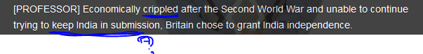

**Submission: give in /surrender /yield to sb; franchise, disenfranchise 剥夺公民的选举权**









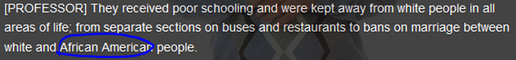

**// PC wording ( political correct): African American, instead of “the black”**









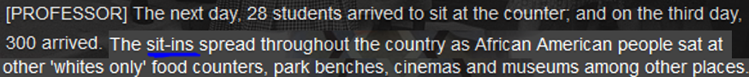



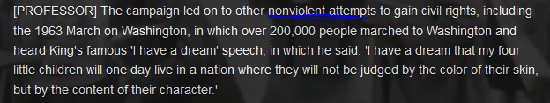





//lift bans on sth; lift limitation on sth; lift sanctions against 取消/取缔（限制；制裁）

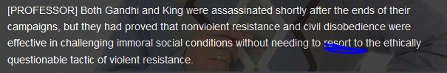

## done mp3) video

Listen to the people talk about government spending on **social issues.**

## Social issues

* health care
* how to take care of the senior
* education
* crime: petty crimes轻罪, e.g. shoplifting, burglary; felony, e.g. murder, arson
* petty crimes V.S. felony V.S. a hanging offence滔天大罪

|  |  |
| --- | --- |
| Petty crimes (minor) | Shoplifting, burglary |
| Felony | Drug trafficking, human trafficking |
| **Hanging offence滔天大罪** | 'It was almost a hanging offense.' means the following  e.g. Once, pretty much everywhere, beating your wife and children was regarded as a father's duty, homosexuality was **a hanging offense**, and waterboarding was approved.  以前，几乎在任何地方，打老婆打孩子都是天经地义之事，同性恋也是 滔天大罪，而水刑也不会招致异议 |

* housing
* env pollution, air quality: the contamination of the natural environment with substances that are harmful to humans.
* traffic jam
* gun control/ gun crimes
* poverty and homelessness
* School **truancy** : the failure of school children to attend school.
* Gang culture : when people, usually of a similar age or ethnic background, form groups together, often to cause trouble or fight.
* Obesity: the condition of having increased body weight because of excess fat; this issue is associated with a host of health problems.
* Vandalism: the deliberate destruction of property that is not your own.
* **Road rage:** the aggressive behavior demonstrated by drivers often as a result of the actions of other road users.  Road rage is anger or violent behaviour caused by someone else's bad driving or the stress of being in heavy traffic. （主要是指驾驶人因不耐前车或不满抢道而引起的愤怒）e.g. Two women were being hunted by police after a road rage attack on a male motorist. 因在一次道路暴行中袭击一名男司机而正被警方追捕
* **racial segregation 种族隔离**

## 2nd row) **Reduced infinitives (**不定式**)**

An **infinitive** is a verb preceded by **to**. E.g. It's necessary **to register** your gun with the police

|  |  |
| --- | --- |
| A **reduced infinitive** is when the main verb is not used, usually because the speaker assumes the listener already knows the topic of conversation. For example: | |
|  |  |
| A: | Did you remember to register your gun? |
| B: | No, I forgot **to**. (No, I forgot **to register** it.) |
|  |  |
| The entire infinitive verb can be eliminated after many verbs, including **forget**. | |
|  |  |
| A: | Did you remember to register your gun? |
| B: | No, I forgot. (No, I forgot **to.** No, I forgot **to register** it.) |

|  |  |
| --- | --- |
| The reduced infinitive **to** is not usually dropped when using the verbs **want**, **like**, **love**, **hate**, **choose**, and **prefer**. For example: | |
|  |  |
| A: | Would you like to own a gun? |
| B: | Yes, I'd like **to**. |

|  |  |
| --- | --- |
| However, the reduced infinitive **to** can be dropped after **want** and is usually dropped after **like** when used with conjunctions such as **when**, **if**, **what** and **as**. For example: | |
|  |  |
| You can go with me to the police station if you want. (if you want **to**., if you want **to go**.) | |

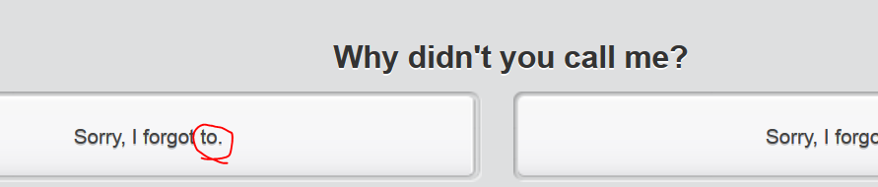

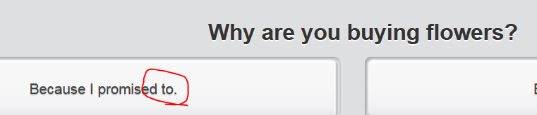 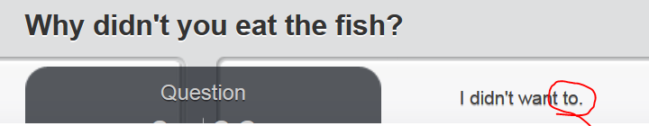

## 3rd row) Discussing social issues – the crimes, esp, the gun crimes

Two friends of yours were recently robbed **at gunpoint (在枪口威胁下)** in their home. You and your friend are discussing gun crime. He believes that everyone should be free to carry guns. You disagree. Oppose his viewpoint.

gunpoint /ˈɡʌnˌpɔɪnt/ [ at gunpoint ] If you are held at gunpoint, someone is threatening to shoot and kill you if you do not obey them. 在枪口威胁下 e.g. She and her two daughters were held at gunpoint by a gang who burst into their home. 她和她的两个女儿被一伙闯入家中的歹徒持枪挟持

## done mp3) video) “gun crime” , a serious “social issue” in U.S.



# Part 4 ) Newspaper

## Stop) Lexical resource

* **Feature article = “soft” news,** Features/feature article are also known as 'soft' news. This might be an article about a local celebrity or upcoming event. => tabloid V.S. broadsheet
* **enough is enough (够了；适可而止)**

e.g. I don't mind good, clean fun, but **enough is enough**.   我并不介意有趣、健康的玩笑， 但要适可而止。

The difference is at some point you say enough is enough. 不同的是在某些要点上你说足够就够了。

* 公正的：不偏见 /不偏不倚的 impartial = unbiased = candid

|  |  |
| --- | --- |
| impartial | impartial /ɪmˈpɑːʃəl/  = unbiased 公正的；不偏不倚的  1.ADJ Someone who is impartial is not directly involved in a particular situation, and is therefore able to give a fair opinion or decision about it. 公正的  e.g. Career counsellors offer impartial/unbiased advice, guidance and information to all pupils. 提供无偏见的建议、指导和信息。  e.g. I believe it is in the public interest for reporters to be as unbiased and impartial as possible.  2.N) 公正 **impartiality [,ɪmpɑrʃɪ'æləti] = fairness** e.g. ..a justice system lacking impartiality by democratic standards.  …以民主标准而言缺乏公正性的司法体系。 |
| Unbiased |  |
| candid | 公正的：不偏见 Free from prejudice and bias; candid = impartial and fair  [candid judgement公正的裁决; candid feedback公正的反馈]  eg In retrospec, it is time to analyze if I possess any of these fatal flaws/defects during my leadership management and ask for **candid公正的 feedback** on your performance in these specific areas.  eg During the APEC summit, the counterparts Obama and Xi will have **"candid公正的坦率的 and in-depth conversations"** on a range of issues. In addition to their meeting, both leaders will deliver statements to the media. But the possibility of taking questions remains the **"sticking point. 关键症结"**  [sticking point: a point, issue, or situation that is likely to cause deadlock/stalemate/logjam/impasse] |
| 以开朗和诚挚为特征的, 坦率的说话率直的，不转弯抹角的： Characterized by openness and sincerity of expression; unreservedly straightforward, frank and blunt: [In private, I gave them my candid opinion. 私下里，我对他们直言相告; [Please allow me to be blunt/candid 请允许我坦白说= frankly speaking; ]  eg I will be quite candid with you, I think you acted foolishly. 我要 **坦率地** 对你说, 你做得很愚蠢。  Eg Frankly/bluntly speaking, I don't like SH, a kind of concrete jungle, making me feel suffocated/smothered窒息. |
| [ **candid photos 生活照**: not posed or rehearsed: 偷拍的照片：未摆好姿势的或事先未安排好的 ] **[ a candid snapshot一张偷拍的生活快照(slang); candid camera (趁人不备时)快拍用的小照相机;]**  eg The **paparazzi [,pɑːpə'rɑːtsiː]狗仔队** is so skilled at taking **candid snapshots** for celebrities, especially for those who are not **photogenic/ˌfəʊtəˈdʒɛnɪk/上镜上照的.** |

* 自拍照: selfie; **[snap a selfie 自拍; the selfie stick 自拍杆]** eg I wanna **snap a selfie**.  **//candid photos 生活照**
* 上镜的上相的 photogenic /ˌfəʊ**tə**ˈdʒɛnɪk/: looking attractive and gorgeous as a subject for photography at camera shooting.   
  eg The paparazzi狗仔队 is so skilled at taking the **candid snapshots** for celebrities, especially the stars who are not **photogenic**.   
  Eg If you are going to be an actress (esp the most sought-after actress 吃香的) or a supermodel, you should have a preparation for not being **photogenic**
* paparazzi [,pɑːpə'rɑːtsiː]  n. 狗仔队（专门追逐名人偷拍照片的摄影者或记者，paparazzo的复数）
* plagiarize /ˈpleɪdʒəˌraɪz/; plagiarism /ˈpleɪdʒəˌrɪzəm/  
  1.V-T If someone plagiarizes another person's idea or work, they use it or copy it and pretend that they thought of it or created it. 抄袭剽窃 e.g. The students denied plagiarizing papers. 学生们不承认抄袭试卷  
  N) plagiarism /ˈpleɪdʒəˌrɪzəm/  Plagiarism is the practice of using or copying someone else's idea or work and pretending that you thought of it or created it. 抄袭剽窃 e.g. Now he's in real trouble. He's accused of plagiarism of another’s patent 他被指控 抄袭剽窃  
  n. 抄袭/剽窃者plagiarist ['pleidʒiərist] = plagiarizer ['pleidʒiə,raizə]   someone who uses another person's words or ideas as if they were his own
* sinkhole /ˈsɪŋkˌhəʊl/ = swallow hole

1.N a depression in the ground surface, esp in limestone, where a surface stream disappears underground 落水洞; 尤指石灰石地面下陷，地表水消失于地下

* infringe /ɪnˈfrɪndʒ/; infringement

1.V-T If someone infringes a law or a rule, they break it or do something that disobeys it. 违反 e.g. The film exploited his image and **infringed his copyright**. 侵犯了他的肖像权。

2.V-T/V-I If something **infringes people's rights,** or infringes on them, it interferes with these rights and does not allow people the freedom they are entitled to. 侵犯sb’s 权利

e.g. They rob us, they infringe our rights, they kill us. 他们侵犯我们的权利，他们屠杀我们。

* public interest: **[ it’s *in the* public interest for sb. to do sth ] V.S. conflict of interest 利益冲突** The public interest refers to the "common well-being" or "general welfare". The public interest is central to policy debates, politics, democracy and the nature of government itself. [ It’s in the public interest for sb to do. ]

e.g.

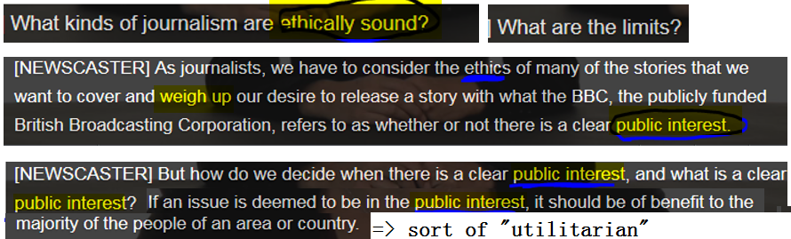

e.g. Any conduct harmful/detrimental to the **public interest** must not be permitted.  凡是损害**公共利益**的行为， 都应该制止。

e.g. Grimes’ office refused to comment on the allegation and also **fended/warded off** the related bribery questions in a press conference, but did insist, “Senator Grimes has always acted in the best **public interests** 公共利益for our state and will continue to do so”

* 中伤， 诽谤

|  |  |
| --- | --- |
| 中伤， 诽谤; 诋毁 | V) **smear sb = defame sb = malign sb = detract**; N) smear = defamation **[,defə'meɪʃ(ə)n];**   1. To smear sb. or defame sb means to spread unpleasant and untrue rumours, scandals, or accusations about them in order to damage their fame and reputation. 中伤， 诽谤; 诋毁; eg They planned to **smear/defame/malign/detract him** by publishing information about his private life. 来**诋毁**他。 2. n) A smear/defamation is an unpleasant and untrue rumour or accusation that is intended to damage someone's reputation. 诽谤; 诋毁 |
| 1贬低/诽谤 2.减去 | detract, detraction, detractive, detractor   * literal meaning: 减去减损If one thing detracts from another, it makes it seem less good or impressive**. [ detact from sth]** undervalue   e.g. They feared that the publicity surrounding him would **detract from** their own election campaigns. 他们担心围绕他的宣传会有损他们自已的竞选活动  e.g. The spread-out rumor has already **detracted from** my fame and reputation 扩散的谣言已经 有损/减损 了我的名誉   * figurative meaning: 减去(sb`s fame) => 贬低/诽谤 **detract/smear/defame/malign sb**   => N) detraction = smear = defamation；减损  => detractor /dɪˈtræktə/ 诋毁者/诽谤者The **detractors** of a person or thing are people who criticize that person or thing.  e.g. His performance will silence many of his **detractors**. 这次表演会让他的很多诋毁者哑口无言  e.g. He, even as one of the most sought-after actors in Korea, still have lots of **detractors** 诋毁者/诽谤者. //吃香的，受欢迎的 sought-after |
| v) 诽谤,中伤 sb **Adj)有害的** | malign /məˈlaɪn/  1.V-T If you malign someone, you say unpleasant and untrue things about them in order to hurt sb's fame and reputation 诽谤,中伤 sb [**detract/smear/defame/malign sb**] e.g. We maligned/defamed him dreadfully when you come to think of it. 我们当时很恶毒地 中伤 了他。 2. ADJ If something is malign, it causes harm. 有害的 malign = harmful [ the malign influence = the harmful influence 有害影响 ] |
| 诽谤,中伤 | fame -> defame sb/malign sb/smear sb/detract sb =>  N) 诽谤 smear, malign= defamation [,defə'meɪʃ(ə)n] = detraction to damage sb's reputation, fame, character, or good name normally by spreading malicious/spiteful/venomed scandals or rumors. 用诽谤的手段损害…的名誉、人格或好名声 [ defamation of sb's character 诽谤人格 ] //malice/spitevenum; malicious/spiteful/venomed |
| eg I will indict/accuse this correspondent for defamation.  eg I will accuse this news press of defamation.  eg He also challenged Roberts' attorneys to make their accusation/indictment in public, rather than through a "privileged legal document in a talkshow" "They will not state on your show, 'Alan Dershowitz had sex with this woman,' " Dershowitz said. "Because if they do that, they're in court the very next day being inditeced for defamation for $100 million." |
| (spoken, oral) 诽谤 | slander /ˈslɑːndə/  1.N Slander is an untrue **spoken** statement about someone which is intended to damage their reputation. Compare . (spoken, oral) 诽谤 e.g. Dr. Bach is now suing the company for slander / oral defamation. 巴赫博士现在正在控告该公司 犯 诽谤罪。 2.V-T To slander someone means to say untrue things about them in order to damage their reputation; slander sb = defame sb 诋毁; 诽谤 e.g. He accused me of slandering/defaming him and trying to undermine his position. 他指控我 诽谤他 并想削弱他的地位。 |
| (书面写的） 诽谤 | libel /ˈlaɪbəl/, libellous /ˈlaɪbələs/ 1.N) Libel is a **written** statement which wrongly accuses someone of something, and which is therefore against the law. Compare . (书面写的） 诽谤 e.g. Warren sued him for **libel** over the remarks on newspaper. 沃伦因为他在 报纸上言论诽谤 而起诉了他。 2.V-T To libel someone means to write or print something in a book, newspaper, or magazine which wrongly damages that person's reputation and is therefore against the law. (书面写的）诽谤 e.g.  The newspaper which libelled him had already offered compensation. 那家 诽谤 他的报纸已经提出赔偿。 • adj libel, libellous /ˈlaɪbələs/(书面的, e.g. 书报、杂志的言论)诽谤性的  If a statement in a book, newspaper, or magazine is libellous, it wrongly accuses someone of something, and is therefore against the law. e.g. ...stories that are inaccurate or outright libellous. ...不准确或完全诽谤性的故事 e.g. A curious aspect of British law is that legislators are allowed to say whatever theywant in Parliament, within reason, without being sued for libel. 不被以诽谤罪起诉。 |
| (在网络论坛)故意发布煽动性文章来诽谤/黑sb., (网络)喷子 | troll   * **(在网络论坛)故意发布煽动性文章来诽谤/黑sb., (网络)喷子**; V) **[ a troll on internet ]** N) You're such a troll 喷子 on internet. => troll somebody: to post deliberately inflammatory articles on an internet discussion board/internet forum, e.g. tweeter, FB, such as bad or sarcastic words in order to defame s/libel sb诽谤, making sb go ballistic (suddenly become very angry 生气，大发雷霆) * If you **troll somewhere** or **stroll somewhere**, you go there in a casual, slow, relaxed, and unhurried way. 溜达闲逛 e.g. I **trolled/strolled** along to see Michael Frayn's play, "Noises Off." 我 **溜达闲逛** 走着去看迈克尔·弗莱恩的戏剧。 * If you **troll through papers, files, photos**, you look through them in a fairly casual way. 随便浏览(报纸,文件，照片) e.g. **Trolling through the files** revealed a photograph of me drinking coffee in Starbucks in Seoul. 我 **随便浏览** 这些文件时发现了一张我喝咖啡的照片。 |

## 1st) row

## done mp3) video: Prince Dana’s death





 

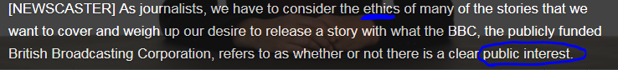













**生活照: candid photos**















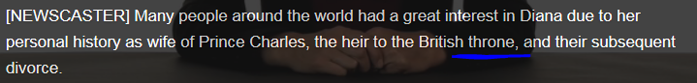





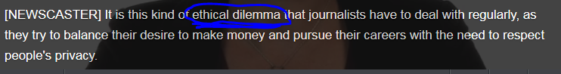

“ethical dilemma”





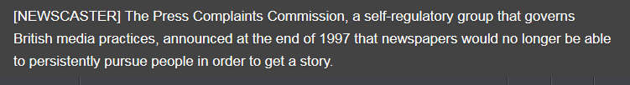

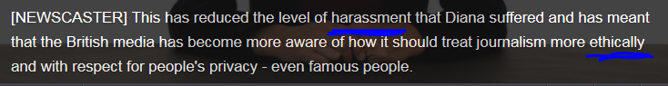



## Stop**) “unethical issues” faced by journalists

There are many ways that journalists can get into trouble when writing stories. The work of journalists is often difficult and **problematic**. Below is a list of definitions of the type of problems that they may face.

|  |  |
| --- | --- |
| **“unethical issues” faced by journalists** | **Definition** |
| A conflict of interest | a situation where you cannot report a story because you are personally involved in or affected by it. A conflict of interest is when reporters write about something that they have a personal interest in.  e.g it is a conflict of interest for him to report on his wife's company. |
| Slander | “say” sth about sb that is not true, defame sb.  E.g. An emoral journalist will libel or slander someone just to make headlines. |
| libel | “write” sth about sb that is not true, defame sb. => libellous /ˈlaɪbələs/(书面的, e.g. 书报、杂志的言论)诽谤性的  Libel is when a reporter lies about someone in print, like in a newspaper article. |
| Plagiarism | a situation where you use somebody else’s material and pretend that it is your own. Plagiarism is when reporters copy someone else's work and claim that it is theirs.  e.g. One of the worst things a writer or journalist can be accused of is plagiarism. |
| Bribery | Including corruption and **embezzlement**, a situation where somebody offers you money or favors to compromise your journalistic integrity. Bribery means giving someone money for confidential information. |
| Copyright infringement | means that a reporter has used copyrighted material without permission. |

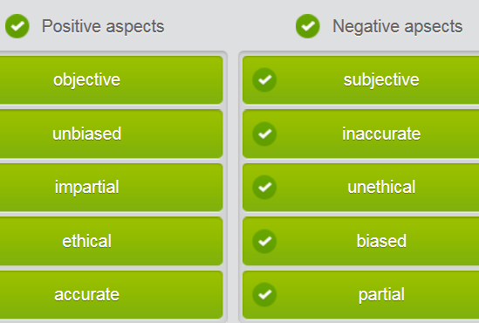

## 2nd row) **the passive voice**

|  |  |  |
| --- | --- | --- |
| The passive voice allows us to emphasize an action without mentioning the person or thing that did it (the agent), perhaps because we don’t know or because the agent is not considered important. | | |
|  |  |  |
| When we do include an agent, it must be preceded by the word **by**. In this case, we normally start a sentence with the information that is already known and save the new information until the end. For example: | | |
|  |  |  |
|  |  |  |
|  |  |

|  |  |  |
| --- | --- | --- |
|  | A: | This article is really interesting. |
| B: | Yes, and it was written **by my brother**! |
|  |  |  |
| The speaker uses the passive to draw attention to the new information - that it was written by her brother. | | |
|  |  |  |
| Sometimes the passive is preferred because the agent is a long clause, which would sound awkward in the active form. For example:  This newspaper is compiled by **journalists who always adhere to the professional code of ethics**. | | |
|  |  |  |
|  |  |  |

|  |  |
| --- | --- |
|  |  |

 The **burglaries** were committed by a local resident.

Journalists are guided by a code of ethics.

Bribes, including corruption and **embezzlement 盗用公款** were taken by the CEO of the company.

The conflict of interest was uncovered by the reporter.

## Reading: attention to the passive voice

A man was arrested last night in connection with the recent **spate of burglaries** in the Hope Valley area. The suspect is being **held in custody** and was **questioned/interrogated** by police overnight about the incidents. He has not yet been named, but police are expected to release further information later. It is likely that he will be charged before the end of the day.

## STOP 3rd row) Write a newspaper article

**[ See unit “News” => tabloid花边小报 V.S. broadsheet (通常比其他报纸严肃的) 大幅报纸 ]**

## Structure of a newspaper article

A newspaper article is normally organized into 4 parts: headline, subhead, leading para, and body.

|  |  |
| --- | --- |
| **Headline** | This is the main point of a story, usually **fewer than 10 words,** written in an **eye-catching style** to **grab readers' attention** and make them want to read the whole article.  Note that headlines often are written **in truncated English**.  e.g. Man shoots self with own gun  e.g. HK sit-ins for universal suffrage |
| **Subhead** | This is a short phrase or sentence, which explains or expands on the headline.  e.g. Local farmer in area hospital in stable condition. |
| **Lead paragraph (shortdesc)** | Summarizes **the key elements** of the article. Journalists aim to answer the five **W** questions. **Who** is the story about? **What** happened? **When** did it happen? **Where** did it happen? **Why** did it happen? |
| **Body** | The remainder of the article follows what is sometimes known as **the 'inverted pyramid' structure**. The elements of the story are covered **in order of importance,** starting with the most important and finishing with the least important. |

## Newspaper/journalistic style

|  |
| --- |
|  |
| The style of a newspaper article differentiates it from other styles of writing. While not every article meets these criteria, it is generally agreed that a newspaper article should: |
|  |
| **Be objective and unbiased/impartial/fair** |
| A generic newspaper article is not an opinion column. Stick to the facts. |
|  |
| **Use precise language** |
| Be as specific as possible in your use of language to avoid any confusion on the part of the reader. |
|  |
| **Back up statements with facts and figures** |
| If you make a statement, be prepared to support it. |
|  |
| **Avoid undue/over amount of word repetition** |
| Why say **eliminate** two times when you can say **eliminate** and **get rid of** one time each? |
|  |
| **Tend toward short words and sentences** |
| If you're writing a newspaper article you're probably pretty intelligent, but you don't need to prove that to the reader. Keep it as simple and straightforward as possible. |

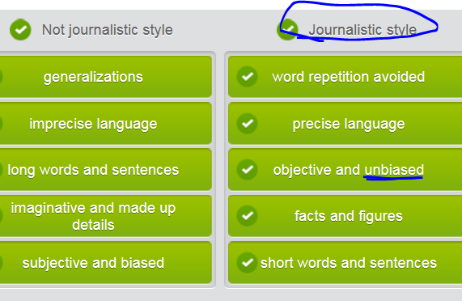

## Different kinds of newspaper articles (see [www.cnn.com](http://www.cnn.com) )

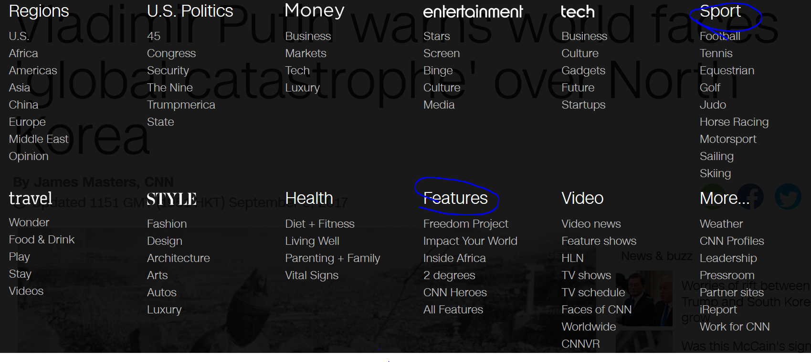

|  |
| --- |
|  |
|  |
| **Local, national, or international news** |
| News articles should be objective and backed up by facts. |
|  |
| **Feature article = “soft” news** |
| Features are also known as 'soft' news. This might be an article about a local celebrity or upcoming event. => tabloid V.S. broadsheet |
|  |
| **Editorial** |
| A subjective essay that appears on a specific page and expresses the opinion of a newspaper or its publisher. |
|  |
| **Column** |
| An article written by the same person on a regular basis. A column could cover almost any topic. A column is not considered to be a news story. |
|  |
| **Sport** |
| An article devoted to sports, the players and the results of games. |
|  |
| **Review** |
| A critic reviews a movie, play, concert or other performing art. |

## Reading a newspaper

**[headline: short and eye-catching ]** Sinkhole Swallows Car

**[subhead]** Residents claim lack of infrastructure funding has made roads dangerous

**[ leading para: 5”W” questions ]** The residents of the small town of Marshview, Florida woke yesterday to the news that yet another car has been swallowed by a **sinkhole/swallow hole** in their town. This marks the second incident in less than three months. Local resident Sam Byers was driving his car along Elm Boulevard when his front tires got stuck in a hole in the road. He quickly got out of his vehicle and watched in disbelief as his car was swallowed by the **sinkhole/swallow hole** in a matter of minutes. "I just couldn't believe my eyes." he said. "Something's got to be done about this."

**[ body: “inverted pyramid”, in order of importance]** Town mayor Alice Meadows said that the poor condition of town roads was due to a lack of infrastructure spending at the state level. She also said that the town did not have the resources or expertise to deal with these **sinkhole/swallow hole** issues on its own and appealed to the governor of the state for assistance. "So far we've been lucky to not have any serious injuries, but we've got to do something about this dangerous situation before our luck runs out." she said.

The **inhabitants/dwellers** of Marshview have started a letter-writing campaign to the governor and state legislators. They describe the terrible condition of the roads in Marshview, and request funds to make repairs and upgrades. "The worst part is that these people in the capital just voted themselves a raise in salary, but they can't fund basic services like road repairs. It's **unethical**!" explained local resident Kevin Jacobs.

The mayor has scheduled a town meeting with all **inhabitants/dwellers** tomorrow evening at Grace Church to discuss the situation. After a brief presentation from the mayor, the floor will be open for questions and comments.

## 4th row) Write a newspaper article

|  |  |
| --- | --- |
| **Headline** | This is the main point of a story, usually fewer than 10 words, written in an **eye-catching style** to **grab readers' attention** and make them want to read the whole article.  Note that headlines often are written **in truncated English**. |
| **Subhead(shortdesc)** | This is a short phrase or sentence, which explains or expands on the headline. |
| **Lead paragraph** | Summarizes **the key elements** of the article. Journalists aim to answer the five **W** questions. **Who** is the story about? **What** happened? **When** did it happen? **Where** did it happen? **Why** did it happen? |
| **Body** | The remainder of the article follows what is sometimes known as **the 'inverted pyramid' structure**. The elements of the story are covered in order of importance, starting with the most important and finishing with the least important. |

## Sample

**[headline: short < 10 words, eye-catching]** Senator Accused of Taking Bribes

**[ subhead ]** Senator’s long unethical/immoral relationship with construction firm’s CEO under scrutiny

**[ leading parg :** answer the five **W** questions**]** State senator William Grimes has been accused of taking bribes in the awarding of state construction projects. Firms competing for state projects have long/**perpetually** 不停的反复的complained that Grimes has seeked favor for Universal Construction. This comes after news reports that Grimes’s wife has been on the payroll of Universal Construction for more than 2 yrs.

**[body: “inverted pyramid”, in order of importance: H, M, L]**

Lawyers representing several firms that have lost out on state projects argue that Grimes’ wife being on the Universal payroll is a **conflict of interest** at best, and criminal bribe-taking (including corruption and **embezzlement挪用公款)** at worst. They are urging state legislators to open an investigation immediately.

“When the last big state project was awarded to Universal, I said **enough is enough (够了；适可而止)**” declared the CEO of Precision Company, a competitor of Universal. “I know for a fact that our bid was competitive with Universal, but we didn’t get a fair hearing.” Other business leaders and legislators have claimed to have suffered similar **discrimination (unequal treatment).**

Grimes’ office refused to comment on the allegation and also **fended/warded off** the related bribery questions in a press conference, but did insist, “Senator Grimes has always acted in the best **public interests** 公共利益for our state and will continue to do so”

## My writing

**[headline: short < 10 words, eye-catching]** Korea Chaebol Heir Sentenced to Prison for Bribery

**[subhead: key elements]** SamSung heir was sentenced to jail for 6 years because of bribery and favor seeking from the impeached South Korea previous president

**[ leading parg :** answer the five **W** questions: who did what, when, where, and why**]**

The heir of SamSung corprate, one the most influential Korea conglomerates, was charged with several business felonies, including bribery, corruption, and embezzlement at the end of last year. Finally, he was convicted by Korea Grand Jury and the verdict claimed that this chaebol heir will be behind the bar for a long haul.

**[body: “inverted pyramid”, in order of importance: H, M, L]**

It was reported that the heir was implicated with the ousted South Korea president, Piao, who got severe impeachment from South Korea parliament. Piao and her confidant sought political favor by accepting the heir’s bribery. As a response, Piao helped the heir to tighten his grip on core departments of SamSung after Samsung’s reorganization.

After their political and business conspiracy were disclosed, the heir was apprehended and detained for a while. Initially, the heir denied all accusations and said he was innocent. Additionally, the heir’s spokesman even announced that he was framed by some malicious board of members in Samsung. However, when law enforcement officials dig more and more solid evidences to prove his wrongdoing, the heir finally admitted few parts of all charges against him, including business scam, corruption, and embezzlement, but denied his interest exchange for the president’s political scheme. He also apologized to the public for devastating public interest.